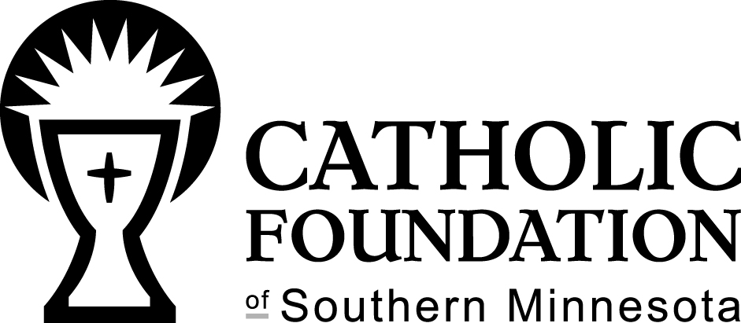

Zach Clark Memorial Scholarship Fund
SCHOLARSHIP APPLICATION
For 2017 – 2018 School Year

Name of Youth__________________________________________ Date____________________

Name of Parent______________________________Email________________________________

Address____________________________________________Phone________________________

Parish you belong to_______________________ School youth attends____________________

In June 2016, the family of Zach Clark created the Zach Clark Memorial Scholarship Fund through the Catholic Foundation of Southern Minnesota. The purpose of the fund is to support youth ministry in the Catholic community across southern Minnesota. Scholarships are available for needy and eligible youth to attend the annual Totus Tuus program, with a smaller portion available for other youth ministry events.

Event Name: TOTUS TUUS SUMMER PROGRAM

DATE OF EVENT ____________________

EVENT LOCATION_____________________

On the back of this application, please write a few paragraphs explaining how a scholarship for Totus Tuus would benefit you. Indicate what you hope to learn from attending Totus Tuus.

Mail completed application to:

Catholic Foundation of Southern Minnesota
Zach Clark Memorial Scholarship Fund
PO Box 30098
Winona, MN 55987

Or deliver to the office at 55 West Sanborn, Winona, MN. If you have questions, please contact Monica Herman, Executive Director of the Catholic Foundation of Southern Minnesota at (507) 858-1276.

Applications will not be accepted at the parish, they must be delivered to the foundation.

Application Deadline: 4:00 p.m., July 1, 2017

The summer of 2015, Zach Clark of Keller, Texas, joined other young adults as a Totus Tuus Missionary for the Diocese of Winona. For eight weeks in a summer, Totus Tuus team members travel the diocese sharing the love of God and encouraging young people to grow in faith. For the first half of the summer Zach traveled with his team and presented Catholic programming, but after a short break over the 4th of July, Zach was tragically killed in a flash flood as he was making his way to Minnesota for the final weeks of Totus Tuus.

The passing of Zach was a very difficult moment for his family, friends and our diocesan community. This young man was an incredible example of joy and faith. His service in our diocese was such a gift and truly changed lives.

To honor Zach’s life, and commitment to Totus Tuus, the Clark family established the Zach Clark Memorial Scholarship Fund. This fund is available to families in need of financial assistance to send their youth to the Totus Tuus program and other youth ministry events. Zach worked hard to share the faith with young people in our diocese and through the Zach Clark Memorial Scholarship Fund, that mission continues on.

The Diocese of Winona and the Catholic Foundation of Southern Minnesota are sincerely grateful to the Clark family for their support of Totus Tuus and youth ministry. We know that Zach continues to be present with us as we work to form the hearts of young people.

