ConnectNow
Family Suite Directory Training Guide

Training Website:
http://connectnow.parishsoft.com/trainingdemo/

User Name: user__
Password: pass12
Live Website: https://connectnow.parishsoft.com/winona

Table of Contents
Family Directory Basics 3
Navigation Basics 3
Main Display 3
Home 3
Family Directory 4
Family & Member List 4
Search 5
Layout 6
E-mail & Mail Merge 6
Filter 6
Export to Excel 8
Quick Reports 8
Family & Member Management 10
Find Existing Family 10
Add a New Family 11
Edit Family / Member 15
Delete a Family / Member 16
Sacramental Data 17
Sacramental Data Basics 17
Sacramental Search 17
Sacrament Entry 18
Edit a Sacramental Record 20
Sacramental Certificates 21
Mail Merge 22
E-mail 25
Family & Member Workgroups 29
Reports 34
My Own Church 36
Suspense Activity 36
How Parishioners Login & What They Can See 37
Administration 39
Suspense 39
Lookups 39
System Setup 39
Organizations 40
Manage Staff 40
Module Setting 42
Additional Resources 43
Teletraining Instructions 43

Family Directory Basics

Navigation Basics

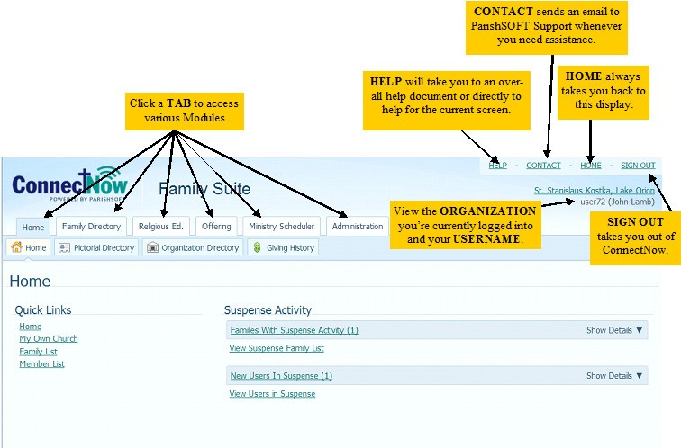
ConnectNow Family Directory helps you keep accurate parishioner and sacramental records for all of your ministries in a convenient browser based system. You can access your data from any device with an internet connection, and backups and updates are automatic.

Main Display

Home
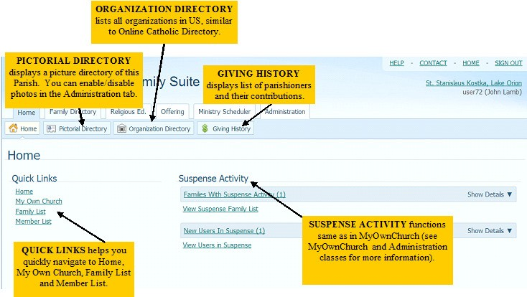

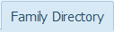
Family Directory
Click the Family Directory tab and view the listing of families in this organization.

Certain concepts are universal to all modules within ConnectNow Family Suite.
  - Change Organizations – If you are a Staff member at multiple organizations, simply click the down arrow at Organizations to quickly change the data set.
  - Alpha/Numeric Jump – click the character to display the records for the selected letter or number.
  - Sort Records – simply click the column header to sort family records as desired.
  - Number of Pages/Records – view the number of records and pages, and jump to a page number as desired.

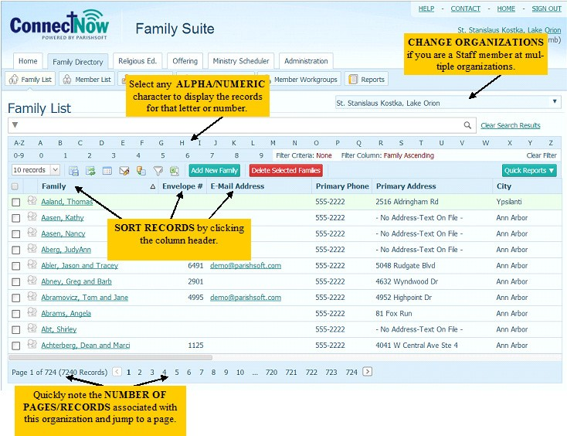

Family List and Member List
Please note that the functionality for these features is the same in Family List and Member List.

Use the Family List when you need to add, update, or delete an entire family, or
if you would like to assign family workgroups.

Use the Member List when you need to update or delete an individual person, or
if you would like to assign member workgroups.

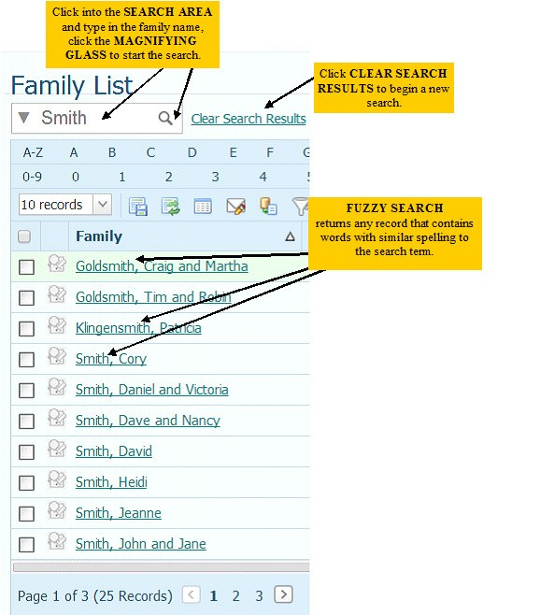
Search

ConnectNow utilizes a “fuzzy search”, which is used to find records that contain words with similar spelling to the search term. This is why you’re seeing the Goldsmith and Klingensmith families.

Click Clear Search Results.

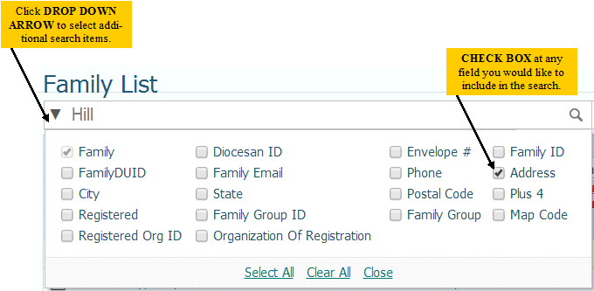
Click the drop down arrow in the Search area to view additional fields you would like to include in your search. Check the box at Address in addition to Family, and enter Hill in the Search area. Click the magnifying glass to begin the search.

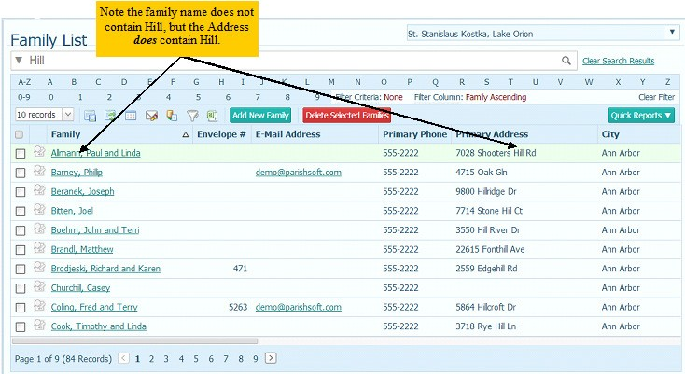
Note that adding additional search criteria of Address now displays families where the address contains the word “hill”.

Click Clear Search Results.

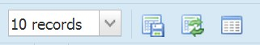
Layout

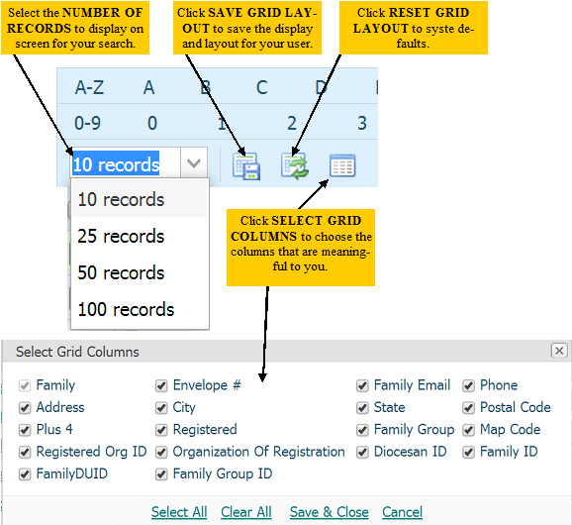
Change from 10 records to 100 records:
Click the down arrow at 10 records and select 100 records. This will display more families at a one time.

Deselect Grid Columns Phone and Email Address:
Click the Select Grid Columns and remove the checkmarks at Phone and Email. Click Save and Close. This removes the columns from the display. Think of the information you’ll want to view on a daily basis.

Reset Grid Layout:
Click the Reset Grid Layout to restore all columns and reset the display back to system defaults.

Email and Mail Merge
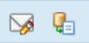
Discussed later.

Filter
There may be times when a simple name search does not suffice in finding the information you need. For those times, you’ll want to use either the basic or advanced Filter functions.

Click the Envelope # column, which makes this column the next filter choice selection. Click the Number 9 in the alpha/numeric filter options.

NOTE: The system will display your filter criteria and filter columns so you can view your choices at a glance.
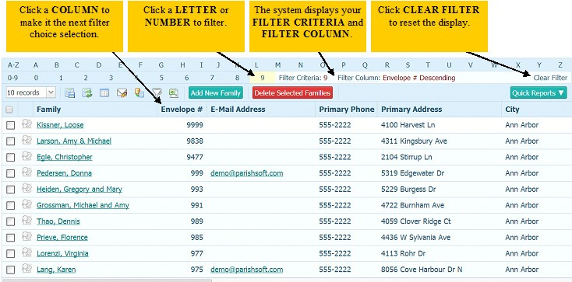

Click the Clear Filter link to reset the filter criteria. Note the filter column continues to be the last column selected.

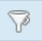
Click the Funnel icon for more advanced filtering options.

Click the down arrow at Membership, Family Group, and Send Envelope to make your filter selections.
Save your filtering selections by clicking the Star icon to the right of the Membership and/or Family Group option.

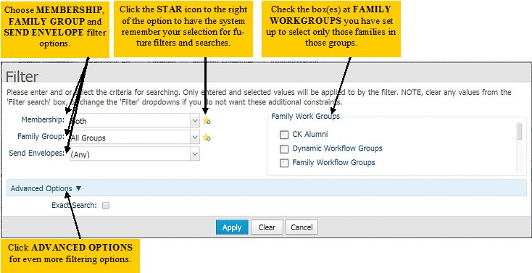

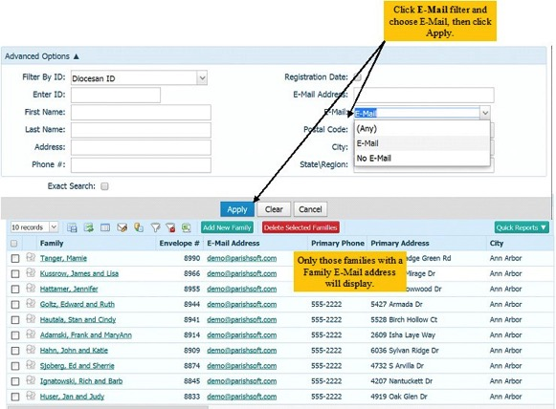

Click the Advanced Options link and additional filter fields will display.

Click Apply when options are chosen.
Click the Funnel X icon 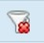 to Clear Filtering.

Export to Excel

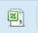
The ability to Search and Filter for families and members relates directly to the ability to export the data to Excel

Click the Export to CSV icon.

Depending on your browser, you will receive a message as shown below:

Internet Explorer
At the message (appears at the bottom of the browser display) “Do you want to open or save FamilyList.csv from connectnow.parishsoft.com?” click Open.

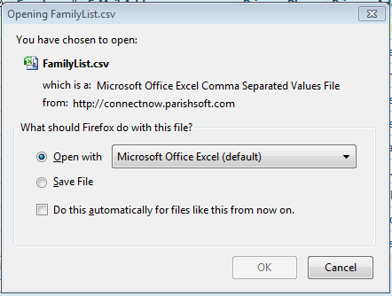
Mozilla Firefox
At the pop-up window that displays, choose “Open With – Microsoft Office Excel (default)” and click OK.
Google Chrome
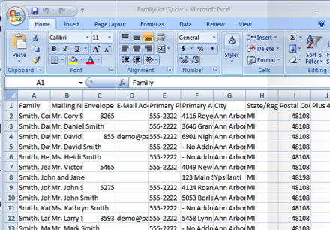
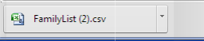
Chrome will display the file in the lower left corner of the browser display. Click the button to display the report.

Export in Excel
You should now see your filtered data in an Excel spreadsheet, where you can adjust the column size, add or remove columns as desired and print as any other Excel spreadsheet.

Close Excel.

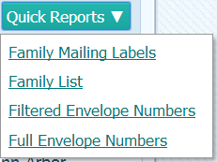
Quick Reports

With Quick Reports, you can produce Mailing Labels and Lists based on the filters applied to your database.
NOTE: The first time you use Quick Reports, you will receive a
Pop-Up Blocker message that may appear differently depending on the browser you’re using.

Internet Explorer
Internet Explorer Pop-up message appears at the bottom of the browser window. Click Options for this site and choose Always Allow.

Mozilla Firefox
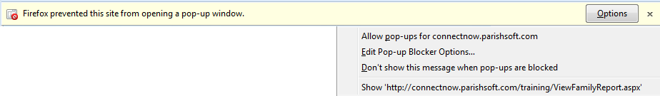
Firefox Pop-up message appears at the top of the browser window. Click Options and choose Allow Pop-ups for connectnow.parishsoft.com.

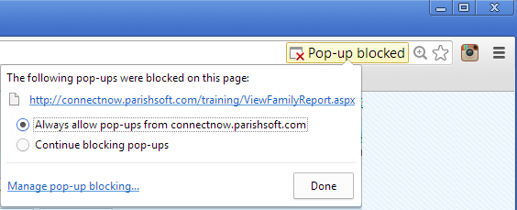
Google Chrome
Chrome’s pop-up message is in the upper right corner of the display. Click the yellow Pop-Up Blocked message and choose Always allow pop-ups from connectnow.parishsoft.com.

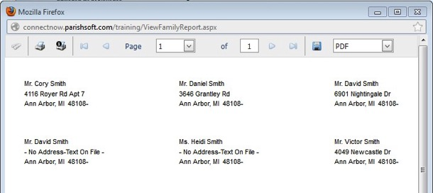
Once you address the pop-up message on this computer for the browser you choose to use, you will not see the message again. You will need to address the pop-up blocker if you choose to use a different browser or if you use a different computer.

Depending on your browser, you may need to click Quick Reports > Family Mailing Labels again after addressing the pop-up blocker message.

You will now see a new window displaying
labels using the standard three columns and ten rows (Avery 5160 Laser) labels.

Family and Member Management
In this section, we’ll learn how to find families, add new families, delete families, and edit family information. The Move Family function allows Parishes in a Diocesan roll out to search for and move families from other organizations. Stand-alone parishes may not have this function.

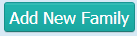
Find Existing Family

Click the Add New Family button.
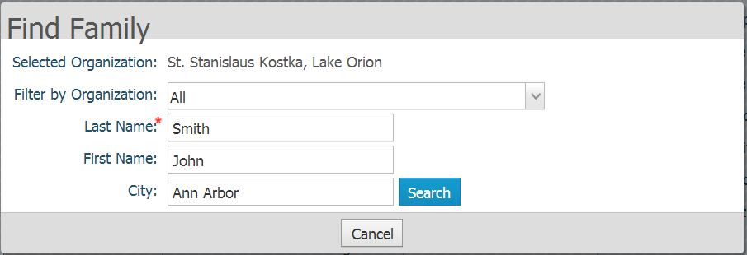
Prior to adding a new family, the system will assist you in finding this families information, even if it is located in a different organization. If the family was previously registered with another Parish, you can move that family to your organization, either as a Registered or Unregistered Member.

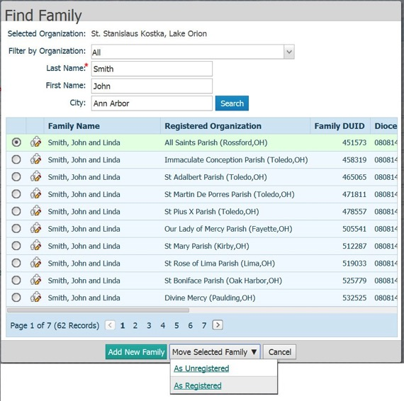
Items with a red asterisk are required fields.
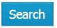
Enter your last name, first name and city.
Click the Search button.

The system will search for and display all matches. Best practices dictate we should always search for the member and move the information, rather than adding a new family and possibly duplicating families within a diocese.

By clicking the radio button to the left of the name, then click Move Selected Family. You can choose to move the family into your organization’s database either as a Registered or Unregistered Member.

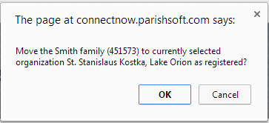
You will receive a pop-up confirmation message “Move the family to currently selected organization as registered?” Answer OK or Yes.

You will then receive a confirmation message telling you the family has been moved. Click OK. You can now search for and edit the family’s information as needed.

NOTE: Contribution information from the previous organization DOES NOT flow into the new organization.

Registered vs. Unregistered
In most US Diocese, a member/family may be registered at only one parish.
However, the member or family may attend mass, send their children to Religious Education or School, etc. at a different Parish. Registered Parishioners are generally included in all reporting, and in diocesan family count and census statistics.

Add New Family
Exercise: Search for and add new family to your organization. Click the Add New Family button.
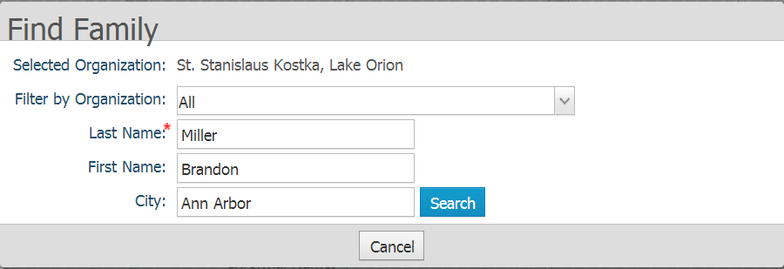
Enter your first and last name.
Click the Search button.
Notice that no other members/families were found that match the filter criteria.
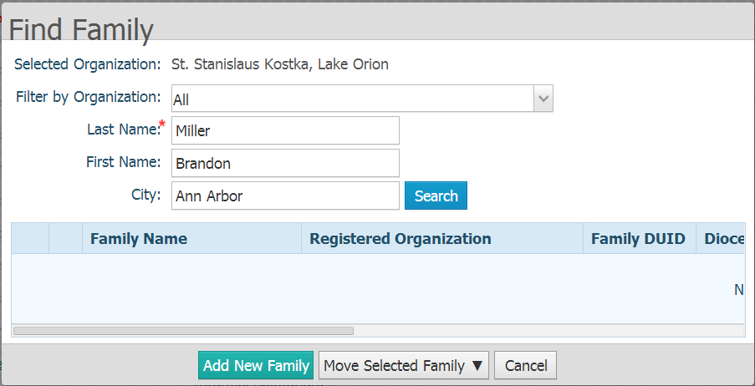
Click the Add New Family button.

Typically, add the members as husband first, and then the wife, followed by other family members you choose to add at that time.

Enter your own family information:

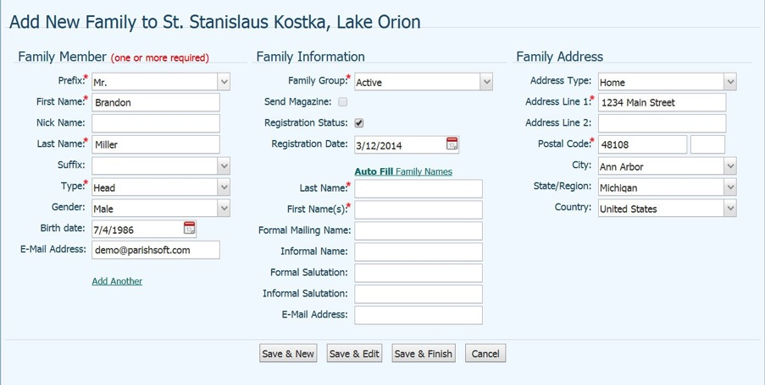

One person in the family needs to be HEAD, HUSBAND or WIFE in the type field.
Postal Code – DO NOT put in city and state. By entering the postal code the postal code will enter the city and state for you.

Auto Fill Family Names – By clicking this it will auto fill the below information from the information that was added on the left.

Below is a description to each field as you enter data.

Field | Description
Family Details Tab
Prefix (ML) | Courtesy or professional title.
First Name* | Member's proper name.
Nick Name | Member's nickname.
Last Name* | Member's surname.
Suffix(ML) | Name suffix that follows the member's full name (for example, Jr.).
Member Type* | Select the member's family role, required field; one person must be defined as Head, Husband or Wife.  - Adult: Adult, no direct relationship to Head, Husband or Wife  - Daughter: Daughter of Head, Husband or Wife  - Father: Father of Head, Husband or Wife  - Foster Daughter: Foster Daughter of Head, Husband or Wife  - Foster Son: Foster Son of Head, Husband or Wife  - Grandchild: Grandchild of Head, Husband or Wife, unknown gender  - Granddaughter: Granddaughter of Head, Husband or Wife  - Grandfather: Grandfather of Head, Husband or Wife  - Grandmother: Grandmother of Head, Husband or Wife  - Grandson : Grandson of Head, Husband or Wife  - Head: Non Married Head of Household  - Husband: Married Male Head of Household  - Legal Guardian: Legal Guardian of Head, Husband or Wife  - Mother: Mother of Head, Husband or Wife  - Other: Doesn’t fit any other role listed  - Son: Son of Head, Husband or Wife  - Step Daughter: Step Daughter of Head, Husband or Wife  - Step Son: Step Son of Head, Husband or Wife  - Stepchild: Stepchild of Head, Husband or Wife, unknown gender  - Unknown: Unknown Relation to Head, Husband or Wife  - Wife: Married Female Head of Household
Gender* | Male, Female, Unknown.
Birth Date | Member's date of birth selected from the calendar
Email Address | Member's email address.
Family Group(ML) | Select the Family Group
Send Magazine | Check box will only be highlighted if your diocese has requested that feature to be turned on.
Registration Status | New family is by default set to Registered. If you have moved the family in, it will follow the choice made at that time.
Registration Date | Default to today’s date, this is true for brand new families and for families that you move into your parish as this is the registration date they entered.
Address Type | Select the Address Type (Home, Mailing or Other).
Address Line 1 | Enter Family’s Address Line 1
Address Line 2 | Enter Family’s Address Line 2
Postal Code | The system will pick the city and state associated with that zip code. If City is not correct, you can chose a different city from the drop down.
Auto Fill Family Names | Click Auto Fill Family Names after Husband and Wife information is entered. To ensure both husband and wife names are included, click Auto Fill Family Names only after both Husband and Wife information has been entered.
Email Address | Enter the family’s email address.
Primary Phone | Enter the family’s primary phone number.
Emergency Phone | Enter the phone number of the emergency contact for the family.
Emer Ph Desc | Enter the name of the emergency contact for the family.
Envelope # | Type the member's envelope number or select Next to let the application assign the next available envelope number to the member.
Annual Gift | Used only in a situation where you are synchronizing with your diocese and they select to turn on; this will be a manually entered field.
Map Code | Can be used to put in codes assigned to areas to group your family geographically. We recommend you work with a third party service to insert the map codes.
Send Mail | Check the box to the right signifies it is ok to send mail.
Send Contrib Env | Check the box to the right signifies it is ok to send contribution envelopes.
Publish Phone | Check the box to the right signifies it is ok to publish phone numbers.
Publish Email | Check the box to the right signifies it is ok to publish email addresses.
Publish Address | Check the box to the right signifies it is ok to publish address.
Publish Photo | Check the box to the right signifies it is ok to publish photographs.
Notes Tab
General | General notes on family. Can be password protected.
Pastoral | Pastoral notes on family. Can be password protected.
Workgroups | Workgroup notes on family. Can be password protected.
Health Info | Health Information notes on family. Can be password protected.
Log File | Records the date and time of additions and edits to family contact information.
Personal Tab
Member Photo (Change/Delete) | Upload or remove a photo from the tab.
Member DUID | Member's Dio unique ID. Non-editable field.
Special Needs | Check the box to indicate that the member has a special need. Then in the box below, enter a description of the special need (for example, allergy, requires wheelchair access, hearing impaired).
Gender* | Male, Female, Unknown.
Prefix(ML) | Courtesy or professional title.
First Name* | Member's proper name.
Nick Name | Member's nickname.
Middle Name | Member's middle name.
Last Name* | Member's surname.
Suffix(ML) | Name suffix that follows the member's full name (for example, Jr.).
Maiden Name | Female Member's surname before marriage.  NOTE: This information is only on the Member’s record and is not Sacramental.
Member Type* | Select the member's family role (for example, daughter).
Status* | Member's membership status in the organization (for example, active).
Birth Date | Member's date of birth selected from the calendar
Birth Place | Member's place of birth.
Age | Member's age. Non-editable field that is calculated based on birth date entered.
Date of Death | Member's date of death selected from the calendar.  NOTE: A funeral record must be created. This information is only on the Member’s record and is not Sacramental.
Religion(ML) | Member's religious affiliation.
Language(ML) | Member’s primary language spoken.
Ethnicity(ML) | Member's ethnic or the racial category the member most closely identifies with.
Marital Status | Member's marital status.
Envelope # | Type the member's envelope number or select Next to let the application assign the next available envelope number to the member.
Send? | Check the box to include the member on envelope list sent to vendor for more envelopes.
General Tab
Father Name | Full name of member's father. Click to conduct a database search to enable the application to assign the father's name.
Mother Name | Full name of member's mother. Click to conduct a database search to enable the application to assign the mother's name.
Mother Maiden Name | Maiden name of member's mother.
Sacrament Remarks | Type any sacrament-related notes in this field.  NOTE: This information is only on the Member’s record and is not Sacramental.
Career Type(ML) | Select a career type from the menu.
Details | Type career-related information in this field (for example, the name of the member's employer).
School(ML) | Select a school.
Education(ML) | Select years of education (education level achieved).
Grad Year | Year the member graduated from high school, or are expected to graduate.
Username | The login name associated with the user's My Own Church login or if a Staff Member.
Soc Sec # | Member's social security number.  NOTE: This is encrypted information and after record is Saved will display only the last four digits.
Aux ID | Auxiliary ID. An external ID (for example, a driver's license number) used to identify the member.
Vendor ID | Vendor Integration ID. An external ID (for example, from an external accounting system) that, from a data perspective, facilitates managing the member's record and tying it to the member's record in that external system.
Member Notes | Use this area to record additional notes about the member.
Contact Tab
Email Address | Member's email address.
Home Phone | Member's home phone number.
Cell Phone | Member's cell phone number.
Work Phone | Member's work phone number.
Pager | Member's pager number.
Fax | Member's fax number.
Misc. Tab
Member Workgroups | List of the Workgroups in which the member belongs.
Member Strengths | Used for Clifton StrengthsFinder® member-talent tracking

* Indicates a required field
(ML) Indicates a Managed Lookup table which can be edited by your Parish Administrator

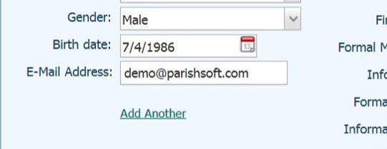
Once you have entered your information, click add another (located in the bottom left hand side of the screen). Enter a spouse’s name and information.

You will notice there is now a View/Delete(1) next to Add Another. By clicking the View/Delete you are able to click on the other member information.

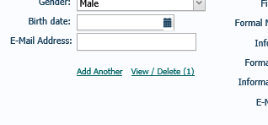

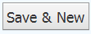

to Save this family and enter a new family.
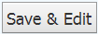
to Save this family and continue to edit this family.
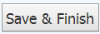
to Save this family and return to the Family List.
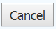
to discard this family and return to the Family List.

Edit Family/Member

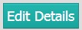
Search for the family or member whose information you would like to change. Using the Search or Filter function, find yourself.

Click your name to display their record and click the Edit Details button.
Make whatever changes are necessary to the family or member as needed. When the changes are complete, click:
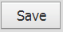
to Save your changes and stay on this family/member’s record.
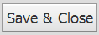
to Save your changes to return to the Family or Member List.

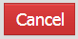
to discard your changes and return to the Family or Member List without a prompt that you will lose your changes.
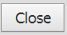
to discard your changes and return to the Family or Member List with a prompt allowing you to choose to close or continue editing and save your changes.

Delete a Family / Member

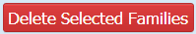
If a member or family was created in error and no data was entered to the family, you may need to delete that member or family. Using the Search or Filter function, find the family. Check the box to the left of the family name, then click Delete Selected Families button.

NOTE: This will remove any active records for Workgroups for the family and members. It will also inactivate any minister or student records.
All contribution and sacrament records will still be available for reporting.
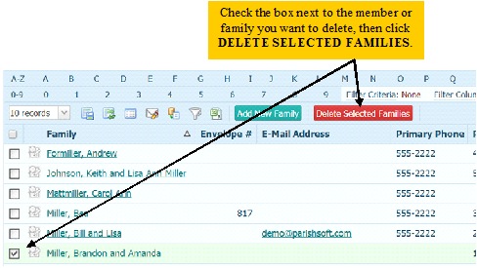

Sacramental Data
Sacramental Data Basics
ConnectNow’s Sacramental Details are modeled after the Catholic canon law requirements. Populate your member records with the most complete sacramental information you have available to you for thorough recordkeeping (i.e. place of sacrament, sponsors, celebrant, etc.). Use your ConnectNow application to print sacramental certificates, populated with information that comes directly from your database.

You can record the following sacraments in ConnectNow:

  - Baptism
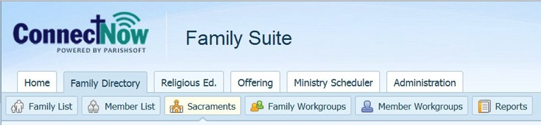
  - Reconciliation Prep
  - First Eucharist
  - Confirmation
  - Marriage
  - Anointing of the Sick
  - Holy Orders
  - Funeral
  - Rite of Reception
  - Religious Profession

Sacramental Search

Prior to entering any new sacrament, you must search for a previous record of the sacrament in the system.

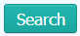
Exercise: Search for an existing marriage record for yourself. Click the down arrow at Sacrament and choose Marriage.
Click Search.
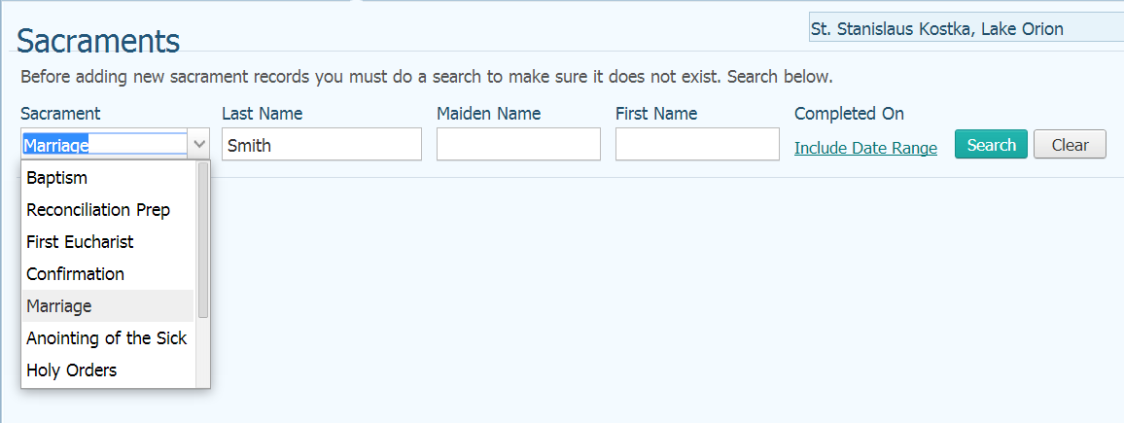

No Sacrament records for you is found, so you may enter this new sacrament in your database.

Click the Create new Marriage record button 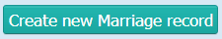. Note that the name of this button will change as you select a different Sacrament.

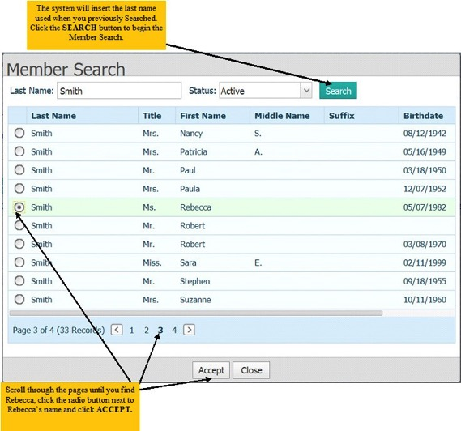
Sacrament Entry

Sacrament of Marriage
Exercise: Create a New Marriage Record for yourself.
The system will remember and insert the Last Name of the person you searched for in the previous exercise. Click the Search button to begin the search.
Since no record was found click create new marriage record.
This will display a Create Marriage record for you.
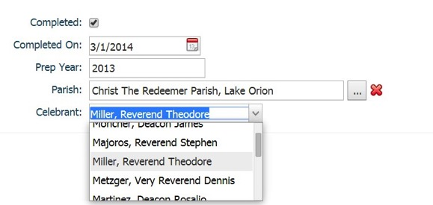
Start by flagging the sacrament as completed by checking the box to the right of Completed.
Enter or look up the date in the Completed On field. Use the date 03/01/2014.
Enter the year the Member prepared for the Sacrament in the Prep Year field. Use the Prep Year 2013.

Click the lookup button to the right of Parish and find then select the Parish where the sacrament was celebrated. Select the Parish you’re currently logged into and click accept.
Begin to type the last name of the Celebrant and select the celebrant from the list. Use the Celebrant Miller, Reverend Thomas.
NOTE: If Celebrant is not listed, contact your Parish Administrator who can add the Celebrant to the Managed Lookups (covered in My Own Church and Administration Class).
You can click the Show Marriage History to view any previous marriages for this member.
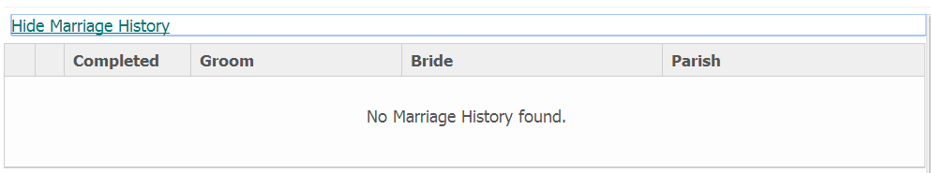

Choose the Marital Status from the lookup table and select from (you can type the first character of the code to jump to that code):
- Annulled
- Divorced
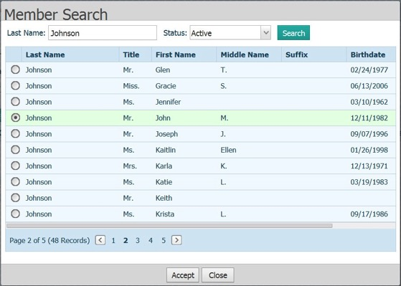
- Married
- Separated
- Unknown
- Widowed
Click the Member Lookup button next to spouse 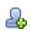 and find your spouse using the same Member Search used previously.

Type the last name in last name field and click Search. Scroll through the pages and click the radio button next to the name and click Accept.
NOTE: If you select the wrong person, click the Remove button 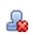next to the member’s name.

Repeat the steps for the Member Search and find the Best Man and Maid of Honor.

NOTE: If the Best Man and/or Maid of Honor are not Members, you can simply type in their name.
If Baptismal information has already been entered in the system, the Baptismal Name, Date of Baptism, Faith of Baptism and Place of Baptism will automatically populate the fields on the Marriage Record display.

Check the box where applicable:

- Canonical - The law of the Church requires for validity that every Catholic marry in the presence of a priest or deacon and two witnesses, using the Catholic form of marriage.
- Banns – Public announcements of the names of those planning on getting married in the Catholic Church for the purpose of discovery of any impediments to a proposed marriage. Mixed marriage banns have been forbidden unless the non-catholic’s religion was not published. In 1983, publishing Banns fell to the local Conference of Catholic Bishops and may be practiced locally, but is no longer required in the US and Canada.
- Disparity of Cult – Marriage between a catholic and a non-baptized person.
- Former Marriage
- Mixed Religion – Marriage between a Catholic and a Baptized non-Catholic.
If recording an Annulment, enter the Annulment ID and Date Ended.

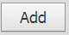
The Title, First, Middle, Last names and Suffix automatically pull in from the Member’s display. Enter the Maiden Name for the Female Member.
Enter the Registry Volume, Page, Number and any General Remarks as needed. Click the Add button to save the information.

Edit a Sacramental Record
Exercise: Search for an existing funeral record for Victor Smith. Click the down arrow at Sacrament and choose Funeral.
Click Search.
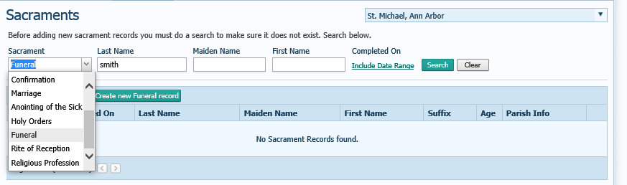

Victor Smith will show below in the list. Click the to edit the sacramental record.
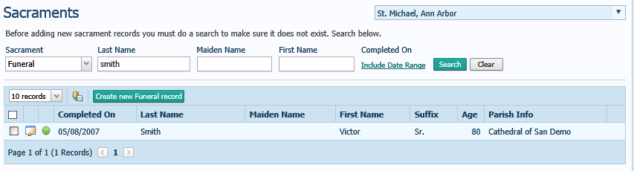

To edit or update a sacramental record click button at the bottom. Once changes are made click save.

Record before editing can be done. Record that can be edited.
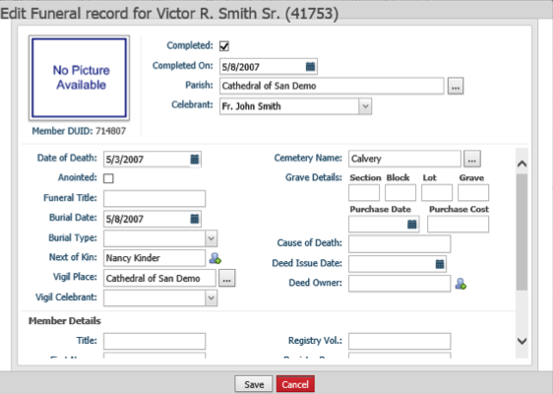
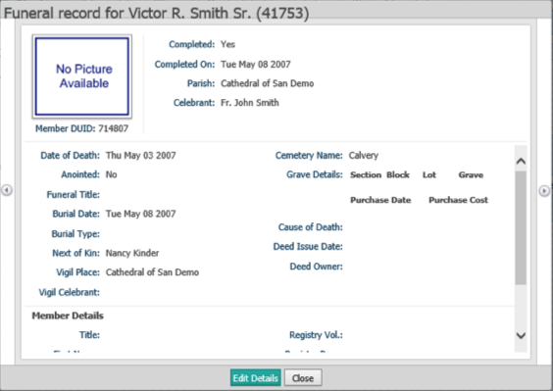

Sacramental Certificates

You can choose to print your Sacramental Certificates using the data in ConnectNow Family Directory with a mail merge function. You will need to have Microsoft Silverlight installed on your computer to perform this mail merge.
Using the Sacramental Search we previously covered, search for the Marriage record for yourself.
You can obtain a free download of Microsoft Silverlight by going to http://www.microsoft.com/getsilverlight and following the instructions on screen to download. If Silverlight is already installed on your computer, you will receive a message stating it is already installed.

Place a checkmark in the box to the left of your name and press the Mail Merge button

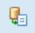
.

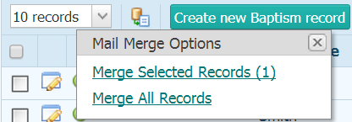
You will be prompted to Merge Selected Records (1) or Merge All Records. Choose Merge Selected Records (1).

When Microsoft Silverlight application opens, be sure to click the Template tab in the upper left corner of the display. At the listing of Templates, choose the ParishSOFT Templates, and a listing of templates will display. Select the Certificate of Marriage Parish Detail and click the Open link.
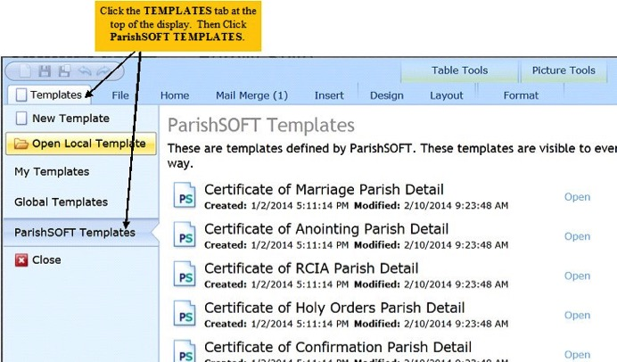

The display looks and functions similarly to Microsoft Word. Click the Merge to Printer icon in the upper right corner to print the Certificates, or click View Merged Data to see your work on screen.
You can print multiple certificates (i.e.Confirmation group) by simply selecting additional members.

View Merged Data – To see work on the screen.
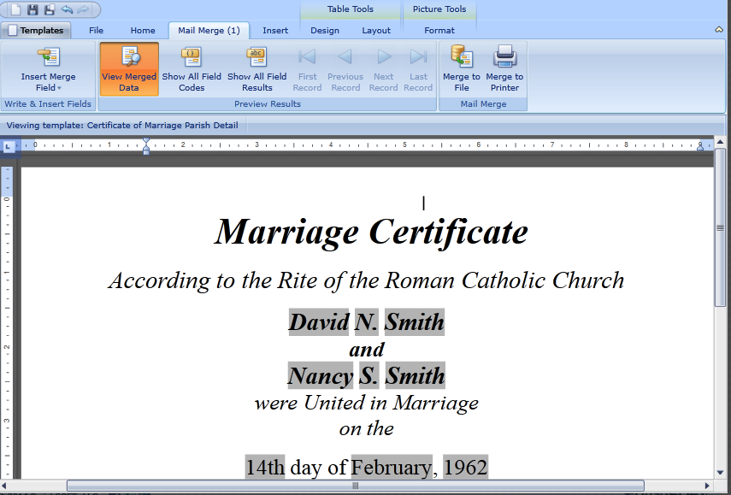
Merge to Printer – To print the certificates.

Mail Merge
Mail Merge can save you much time and energy. You can create word processing templates for your parish for letters you commonly send to members. Then use those templates to generate mailings to the families and members in your database.

Exercise: Send personalized Welcome Letter. Click the Family List button located under the Family Directory.

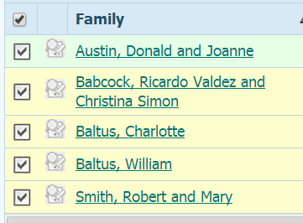
Click the Filter button and select the following:
Membership = Registered
Click Apply.

Click the five families in the list.

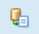
Click the Mail Merge button and choose the Merge Selected Records (5) option.
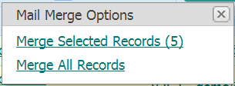

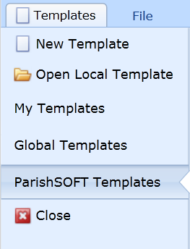
Click the Templates tab and select ParishSOFT Templates.

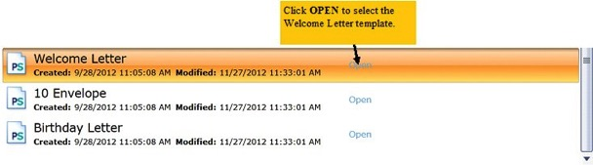
Scroll down the list of ParishSOFT Templates and click Open at the Welcome Letter.

You can now:

Insert Merge Field – Allows you to insert a field of data anywhere on the letter.

View Merged Data – Displays the family information on the letter.

Show All Field Codes – Displays the merged data on the letter.

Show All Field Results – Toggles between merged data and field codes.

First, Previous, Next, Last Record – Allows you to scroll through each family’s letter.

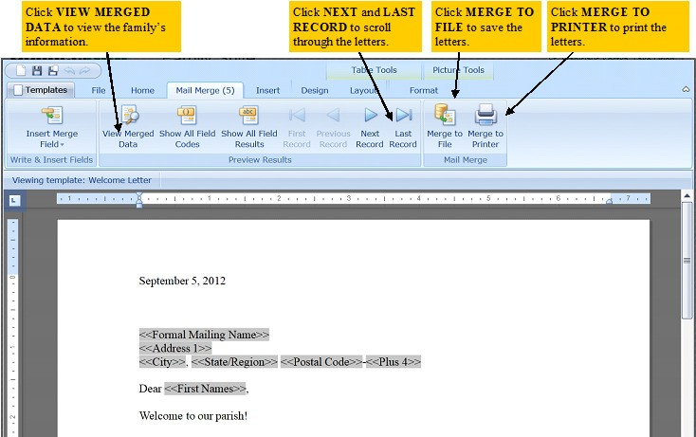
Merge to File – Allows you to save letters locally.
Merge to Printer - Allows you to print letters.
As well as use the other ribbon options to format the letter as desired.
Close Microsoft Silverlight display.

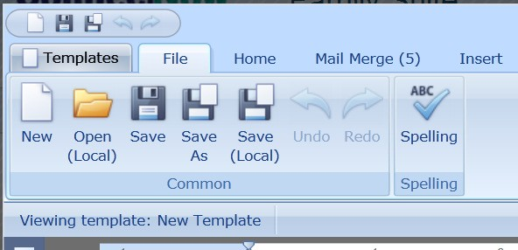
Create new Welcome Letter and save as Global Template.

If you already had a Welcome Letter that your Parish uses, simply click Open (Local) and find and select the file. You can then turn that letter into a Mail Merge template.
If you do not have a Welcome Letter, you can create one from scratch.
Click the Mail Merge ribbon.

Click Insert Merge Field and select the following fields:

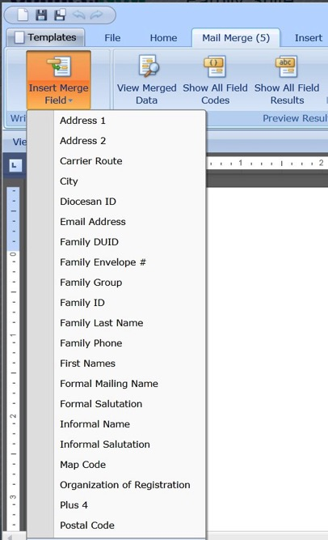
      - Formal Mailing Name <press enter>
      - Address 1 <press enter>
      - City <type comma and space>
      - State/Region <type space>
      - Postal Code
Then click View Merged Data and the first family name will display.

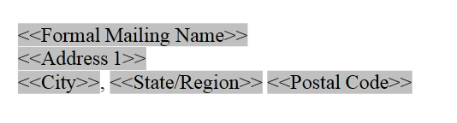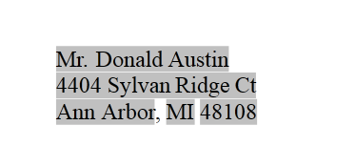

Close Microsoft Silverlight display.

The Templates ribbon is where you can find your templates or create new ones.

New Template – Takes you to the File ribbon to start a new template.
Open Local Template – Allows you to look at your local computer for a current word document you want to create into a template.
My Templates – The templates you have created. Open previously created templates, edit as needed, and choose to make a global template.
Global Templates – Templates shared throughout your Parish.
ParishSOFT Templates – Predesigned templates that ParishSOFT has created for you to use.

Other ribbons available in Microsoft Silver light:

File - Has standard file menu items such as New for creating the new template, Open (for opening a template you have saved on your local computer) and the Save; where you can save to your Connect Now Templates or save to your local computer.

Home - Here is where you find all of your formatting options when you are creating a new template or editing an existing template.

Mail Merge - You can see at the top of the tab in parentheses the number of records that will be merged from you filtered selection.

Gives the standard mail merge fields including viewing your merged data, and moving between records within your merged template. You can also save your template as a .doc or .pdf file after you have displayed your merged data as well as print your merged document.

Table Tool - Design and layout for inserting a table into your template.

Format - Formatting pictures inserted in your template.
Email

The email feature functions similarly in all modules in ConnectNow Family Suite. While we will, you can email groups from the Family List, Member List, Family Workgroup and Member Workgroups as needed. You can send an email using any filters and any groups we’ve covered in the previous training that you desire.

ConnectNow Family Suite will use your email client if it is Web based or Outlook based.

Certain web based email providers will allow ConnectNow to place a copy of the email in your Sent folder, some of these are:
- Parishmail
- Gmail
- Hotmail
- Live
- AOL
- Yahoo Premium (paid service)
Microsoft Outlook Email
You can choose how you’d like to send your emails:
To – Everyone sees who is on the list and everyone else’s email – your email is always here so you have a copy.
CC – Carbon Copy will follow the same as To and everyone will see all email addresses.
BC – Blind Carbon Copy is recommended as each recipient will see their address and the To address and that is all. This option provides privacy to your parishioners.
If you choose to use Outlook to send your email from ConnectNow, you must use Microsoft Internet Explorer as your browser for ConnectNow Family Suite as Outlook will only allow communication to correctly pass information between Microsoft products.
There may be some setup required for proper communications
between Internet Explorer and Outlook. You may receive a pop-up message explaining the process if the setup is required. You will also need to enable the Active X control in Internet Explorer, and again you will receive a message if this is necessary.

Exercise: Email all Active Registered Families in the database.

Click the Family List button 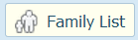 located under Family Directory. Click the Filter button and select the following:
Membership - Registered Family Group = Active
E-Mail = E-Mail (click Advanced Options to view this selection)

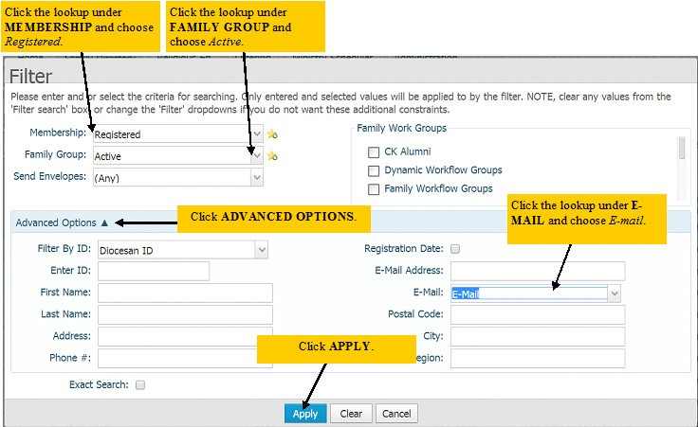
Click Apply.

Now only those Registered, Active families with an email address will display in the grid.

Click the Email button and you will see the View Recipient List.
Note that the Unique Email Count is zero. This is because we did not select the families from the previous display.
Click the Load from Grid link in the upper right corner.

The View Recipient List now displays the families from the previous display. Also note that you will only see unique email address; each family will receive one email from you even if their email address is duplicated in the system.

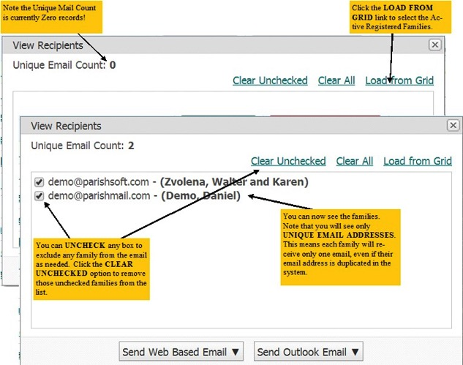
You can manage your list using the following options:

Clear Unchecked - You can choose to uncheck the box next to any family who should not receive your email. Clear Uncheck will remove the family from the list altogether.
Clear All – You can clear the entire list removing all who are checked and unchecked.
Load From Grid – You can reset the View Recipients list back to your original filtered list. Use this to populate the View Recipient display, and to reset the display even if you previously cleared families from the list.

Click the Send Web Based Email button , and then choose BCC (blind carbon copy).
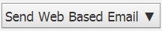
Enter your email address in the FROM: field and your email password in the PASSWORD: field. If you would like the system to remember your email address and password for future emails sent from ConnectNow, check the box at SAVE CREDENTIALS.
Notice that your families email addresses are in the BCC: field, which is a “blind carbon copy”. Using the BCC field ensures your family’s privacy by preventing each recipient from seeing other recipient’s email addresses.

You’ll notice that there are familiar formatting tools allowing you to customize the body of your email message however you’d like.
You can even add up to three email attachments. However, remember that attaching many or large attachments may take longer to send to your families. Also, some email providers may block your email due to the size and/or type of attachments.

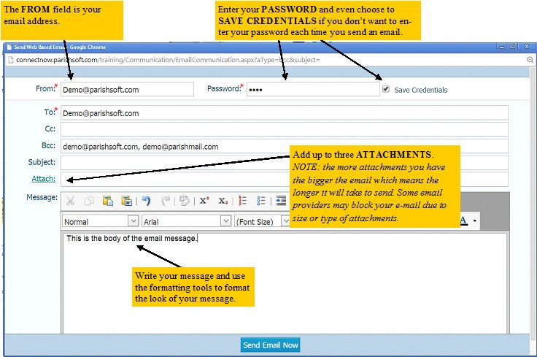

Close this window without sending the message.

Family and Member Workgroups
Family and Member Workgroups allow you to group families and members together in your database for reporting and communication. You can create workgroups for whatever you might need (i.e. Snowbirds, School Families, Choir Members), add the families/members and use the Email and Mail Merge communication tools to keep those families/members informed of group related news.
You can choose to work with Family Workgroups, if the group you want to create relate to the entire family unit (such as Snowbirds where, the entire family moves to Florida in the Winter), or Member Workgroups, if the group you want to create relates directly to the individual member (such as Choir Member, where only one member of the family is in choir).
We will be using the example of Snowbird families. But the process of creating new workgroups and adding families/members will be the same regardless if you’re using Family Workgroups or Member Workgroups.

From the ConnectNow Family Directory tab, click Family Workgroups.

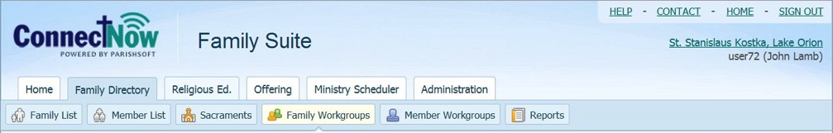

Available Workgroups are on the left side of the display. Simply click the name of the workgroup to display the list of Families/Members in that Workgroup on the right.

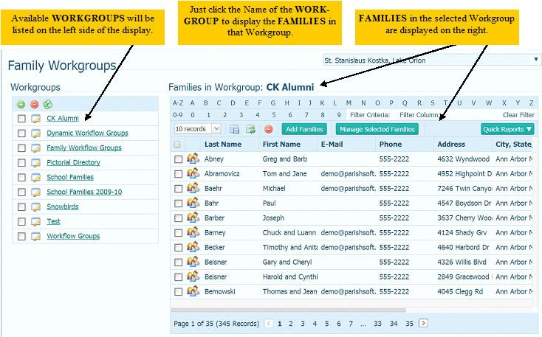

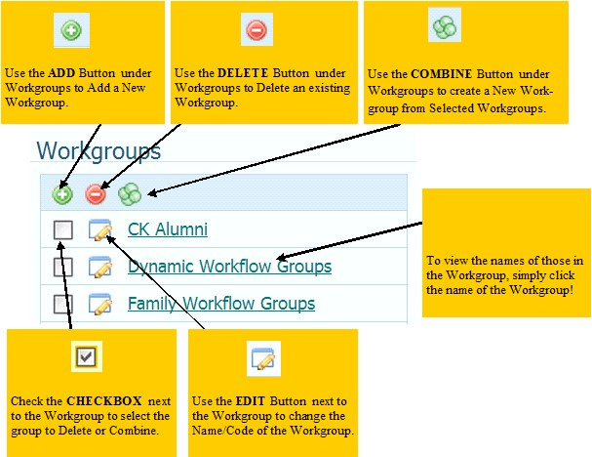
Use the Add Button 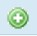 under Workgroups to Add a New Workgroup.

Use the Delete Button under Workgroups to remove all families/members from the workgroup and Deletes the Workgroup.

Use the Copy Button under Workgroups to create a New Workgroup from Selected Workgroups. The original workgroup stays intact.

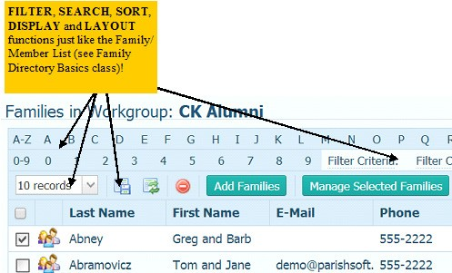
The Filter, Search, Sort, Display and Layout in Family and Member Workgroups functions just like the Family Directory! See the Family Directory Basics class for a refresher if you need more information.

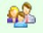
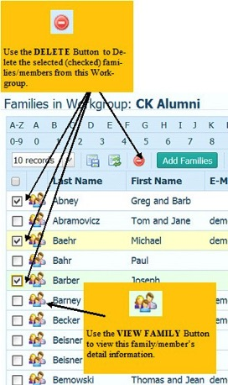
Use the View Family Button to view this family/member’s detail information.
Check the box to the left of the families/members and click the DELETE button to remove the family from the Workgroup.

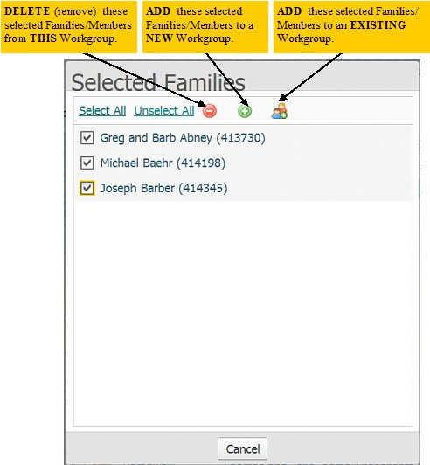
Select a few Families/Members and click the Manage Selected Families/Members button
where you can:
Use the Delete Button to remove the selected families/members from the current Workgroup.

Use the Add New Button Add the selected families/members to a New Workgroup.

Use the Add Existing Button 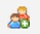 to add the selected families/members to an Existing Workgroup.

Exercise: Add a new Family Workgroup called Snowbirds.

Click the Family Workgroups button 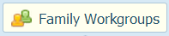located under Family Directory.

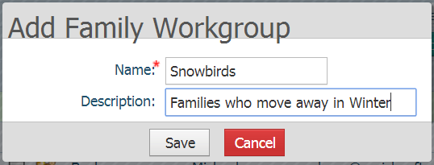
Click the Add Button under Workgroups to Add a New Workgroup. Enter the name of the Family Workgroup = Snowbirds.
The Name of the Workgroup is a required field.

Enter the Description if additional information would be helpful, but not a required field.

Click Save button 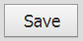.

Snowbirds workgroup is now added to Family Workgroup list; click the Snowbirds workgroup. Notice the No families found message in the area just below the column headers.

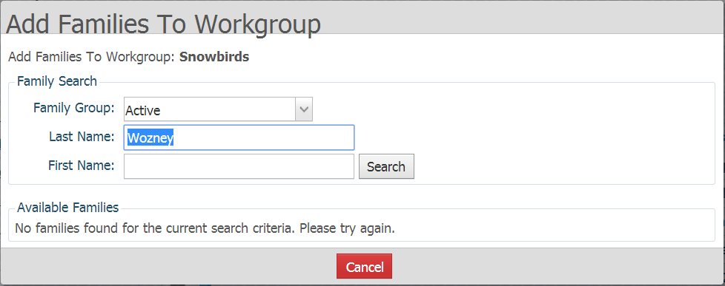
Click the Add Families button .
You can search for Families by Last and First Name, as well as their Family Group.
Enter the last name Wozney and click Search button

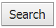
.

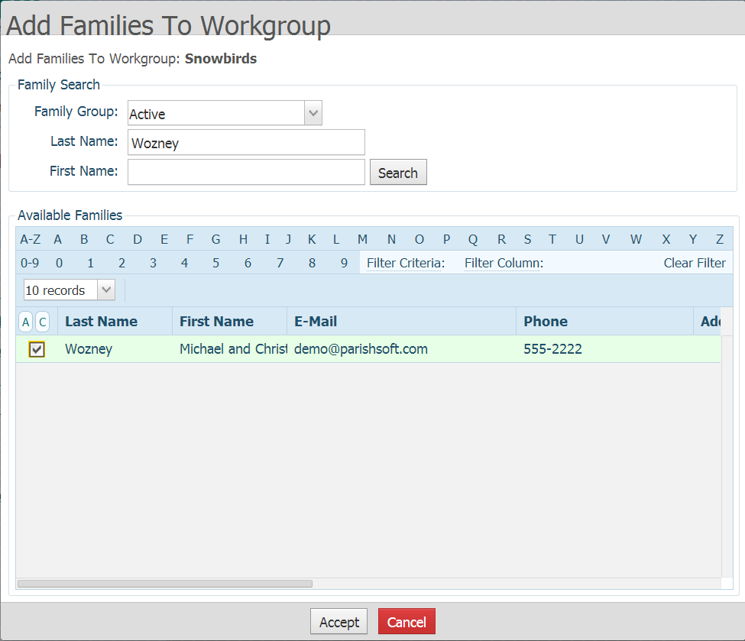
Check the box next to to the Micheal and Christine Wozney family and click the Accept button 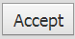.

You can also search only by the Family Group and scroll through all Active families in your database.
Click Add Families button and set the Family Group to Active, but leave the Last Name and First Name fields blank. Then click Search.

You can now find families by selecting the alpha numeric characters in the rolodex and scrolling through the various page numbers. Check the box next to your Snowbird families.
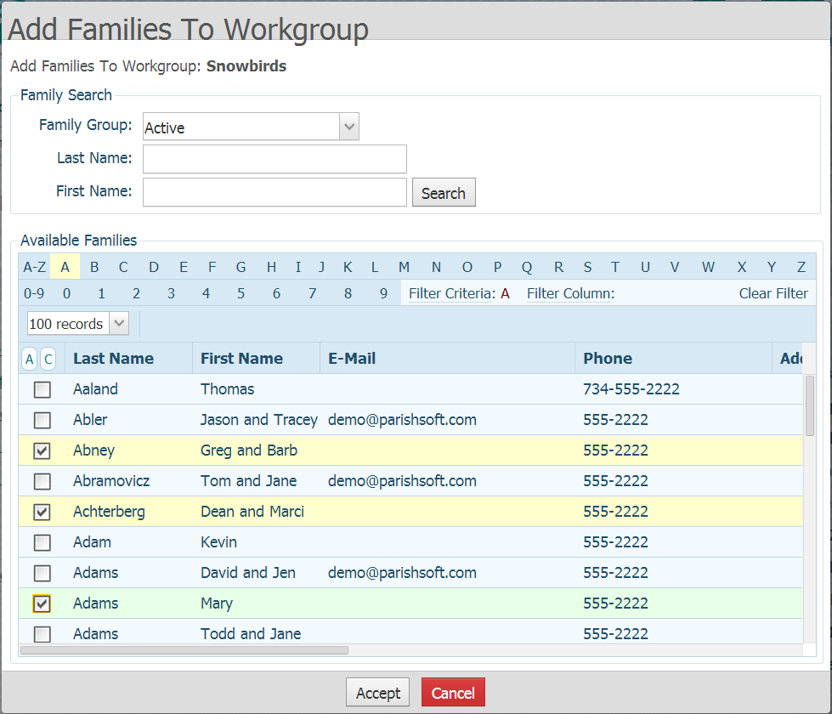
Select three families, then choose another alpha page and select another three families. When you have them all selected click the Accept button .

Exercise: Copy Member Workgroup Festival Committee and create new group called Church Picnic.
There may be times when you have a group of families or members that are similar or identical to another group already set up in the system. In these situations, it’s best to copy the group

Click the Member Workgroups button 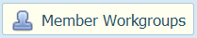 located under Family Directory.

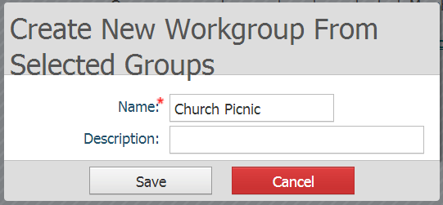
Check the box at Festival Committee under Workgroups on the left side of the display. Click the Copy Button under Workgroups to
create the New Workgroup called Church
Picnic that will have the same members as the Festival Committee. Remember, the description is optional so you can leave it blank and click Save.
You can now refine your Church Picnic group by deleting those Members
who were in the Festival Committee workgroup but are not also in this group, and add members who were not in the Festival Committee group who are in the Church Picnic workgroup.

The Members you add or remove from the Church Picnic workgroup will not affect the Festival Committee workgroup.

Reports

Reports are classified in 3 types: Sacrament, Statistics and Census. Reports are then broken down by each type as follows:
Sacrament
- Baptism
- Confirmation
- Funeral
- First Eucharist
- Confirmation
Statistics
- Kenedy Statistics
- Parish Statistics
Census
- Parish Directory
- Registration Forms

From the ConnectNow Family Directory tab, click Reports.
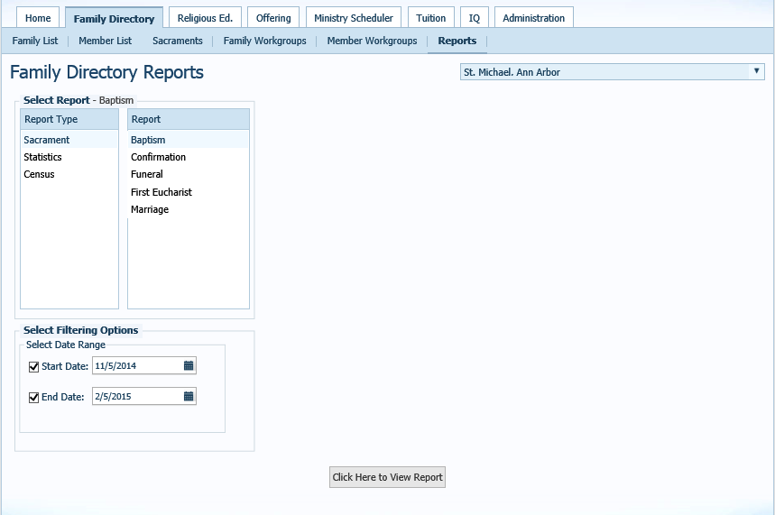
Filter by Date for Sacraments and Statistics.
Click to View Report
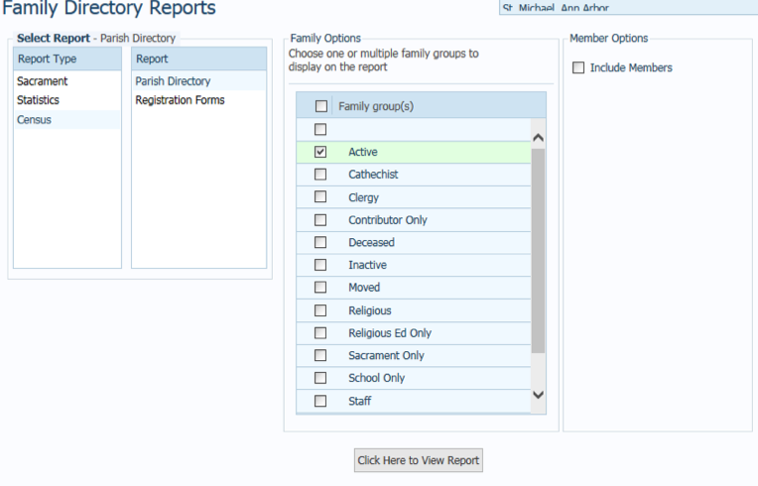
Exercise: Print a Report
- Click Census

- Click Parish Directory

- The Family Options will come up and you are able to check the box next to the group of what you would like to have in the report. Click Active.

- Click the Click Here to View Report button.

Below is what the report will look like.
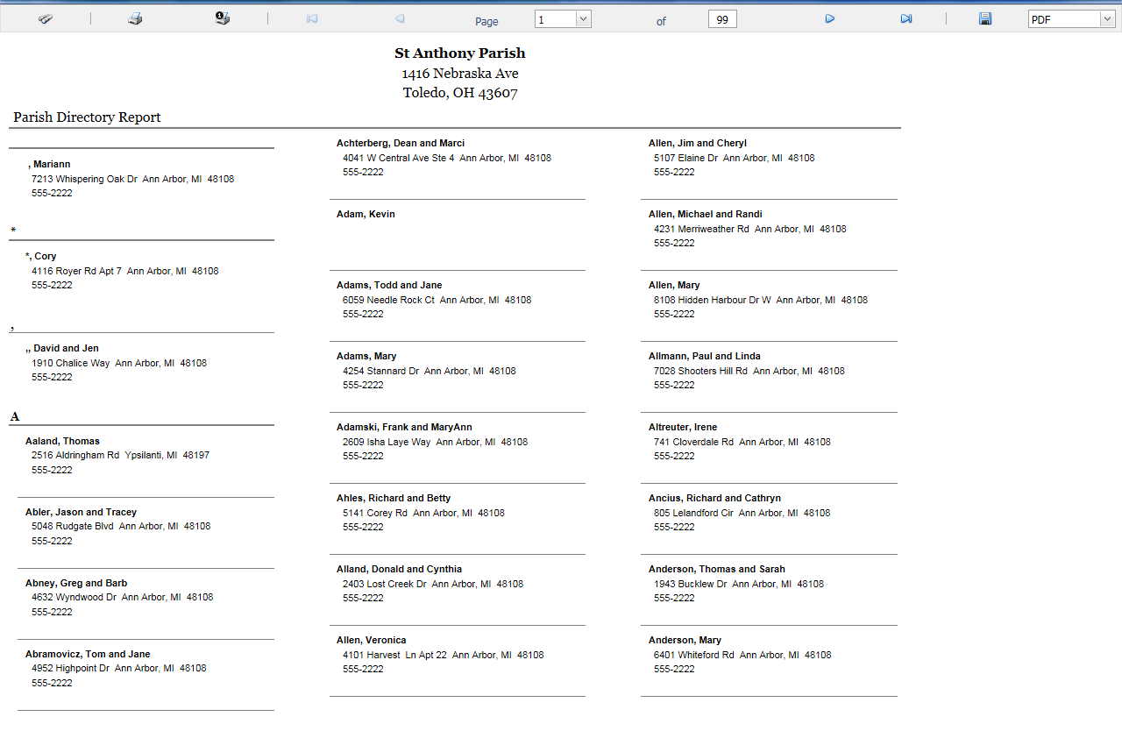

My Own Church

My Own Church is your Parishioner’s portal to their records in your ConnectNow Family Suite. Parishioner’s can register online, or update church records for the family or members. Additions and changes must be approved by a parish staff member.
Parishioners who make changes to their records do see the change on their own record. However, system wide changes are not made until those changes are approved by a staff member.
Only users with Parish Administrator rights will be able to work in My Own Church Suspense Activity and Administration.
Suspense Activity
When a parishioner registers or makes changes to their family or member records, those additions and changes are held in suspense until a parish staff member approves or denies those changes.
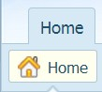
Exercise: Review Suspense Activity.

Click the Home tab in ConnectNow Family Suite.

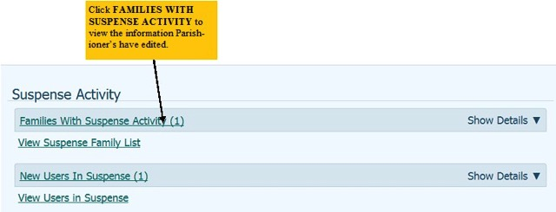
You can view the New Users and Families with Suspense Activity directly on the Home tab.
Click the hyperlink at Families with Suspense Activity to be redirected to the Administration tab.
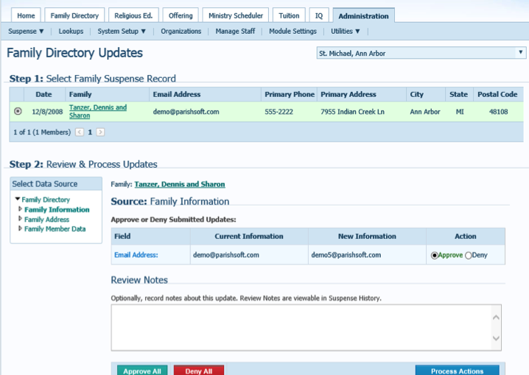
You can view the Suspense List displaying all families who have edited their information.

In this instance, the family wants to change their email address.

APPROVE ALL – Click Approve All if all of the changes listed are acceptable and you wish to publish the changes system wide.
PROCESS SELECTION – If some changes are acceptable and others are not, click the Approve button next to those acceptable and the Deny button next to the unacceptable and click Process Selection.

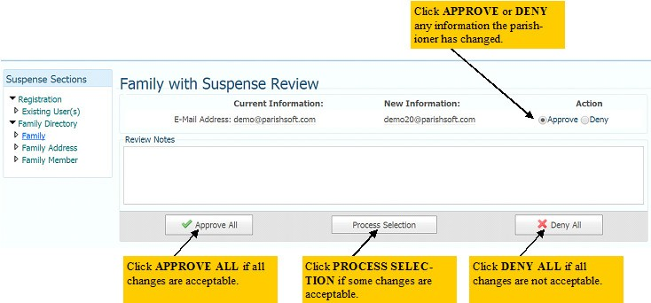
DENY ALL – If all of the changes submitted are not acceptable, click the Deny All button.

Click Approve All.

How Parishioners log in and what they can see
Parishioners will need to go to https://connectnow.parishsoft.com/winona to setup their user name and password. They will need to click on New User and then fill out the registration form. Once they click submit registration a staff member will approve or deny the registration.
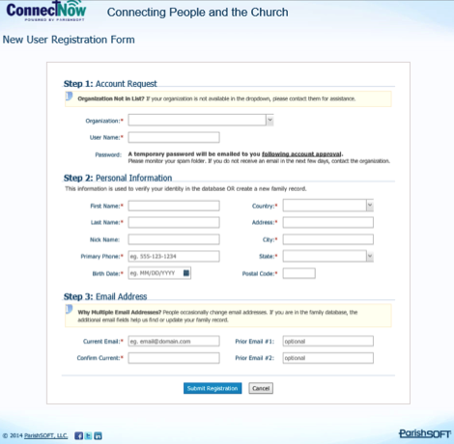

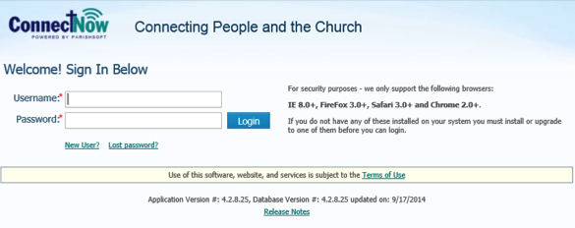

Parishioners are able to see their own information only.
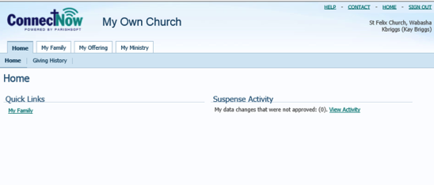

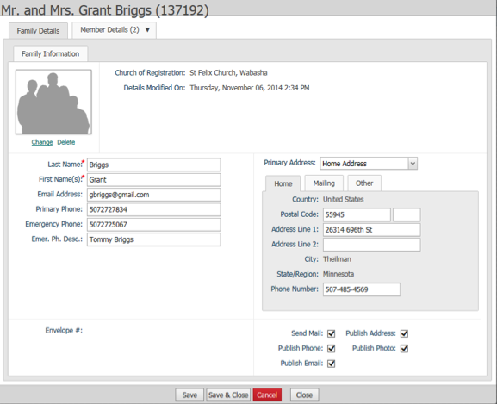
Parishioners can view and update their personal information. Parishioners no longer need to contact the parish office to give staff the change information.

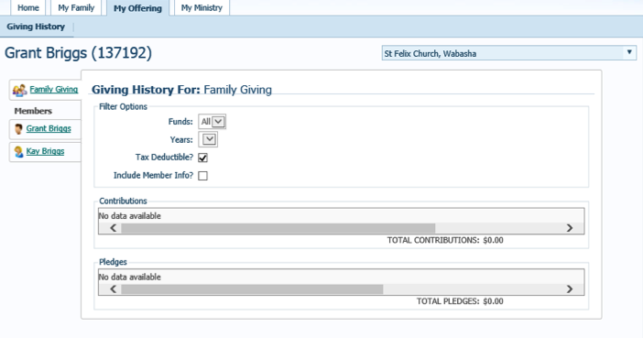
Parishioners are able to look at family giving instead of contacting the parish office.

For the end of year statement for tax purposes, IRS verbiage is not on the document and cannot be used for tax purposes. An end of year statement will still need to be given to parishioners.

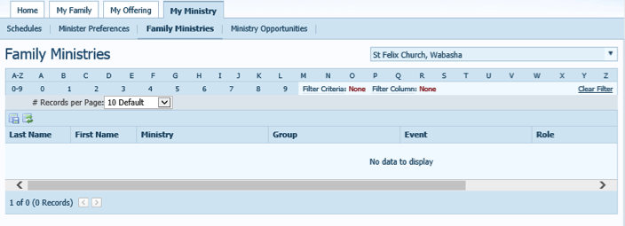
My ministry gives parishioners access to to:
- Schedule
- Member Preference
- Family Ministries
- Ministry Opportunities

Administration
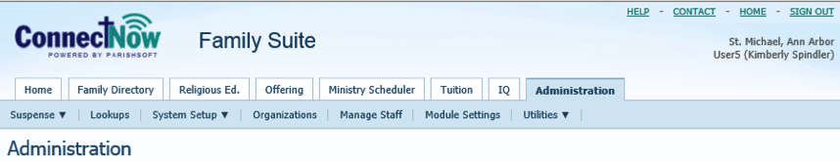

Suspense
Discussed on page 35

Lookups
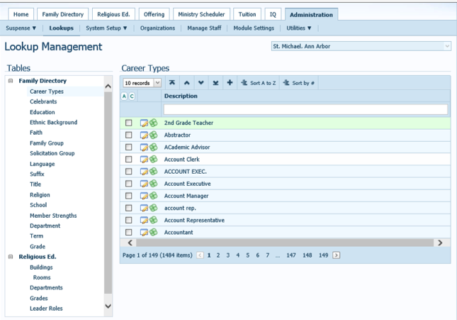
Lookups are groups of information that you are able to choose from when entering data into ConnectNow. For example, when entering a new parishioner into ConnectNow a list is provided for career type to choose what closely relates to the career the parishioner is in.

System Setup
Organization Licensing / System Administration - Gives information on the system
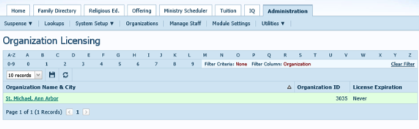

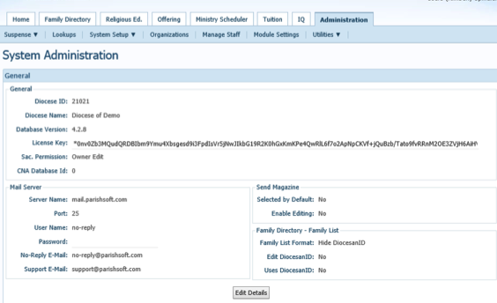

Organizations
Parish Information – this is where you can update information on the organization.
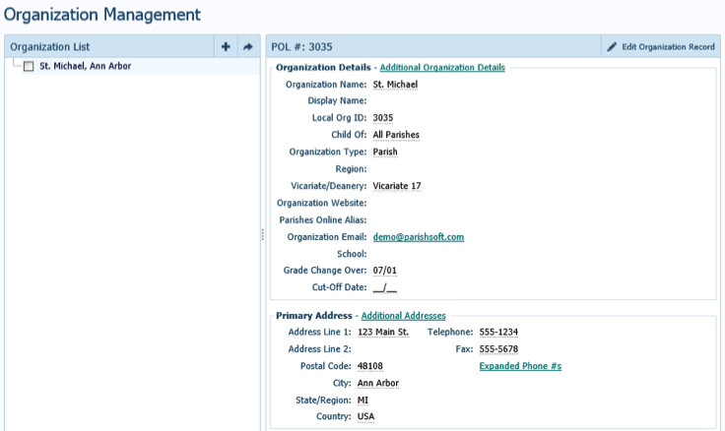

Manage Staff
This section is to add, manage and delete staff. You are also able to give access to staff and reset passwords.

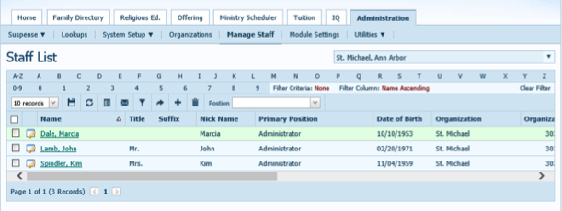
Exercise: Add yourself as a staff member.
In the administration tab click manage staff.

Click New

Enter your name and click search. If you are not in the list click add new staff. If you are a parishioner click the circle next to your name and click accept.
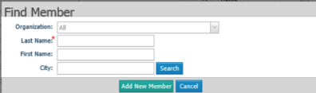

In this instance click add new staff and enter your information.
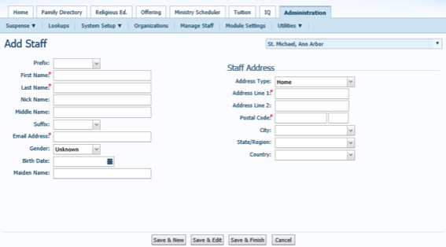

Once all information is added click save and finish.
Once saved, click on your name to add more information.
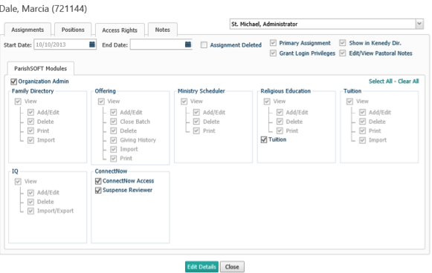
Access Rights – To give access rights to staff

Click Edit Details
Click the appropriate boxes for access rights.

Be sure Grant Login Privileges and ……… are checked, if not check the staff member is unable to login.

Once completed click save.

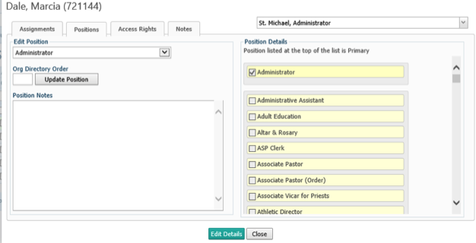
Positions – To add job title to staff member
Click Edit Details.

Go through the list on the right and click the job title that the staff member has.
Once chosen the job title will move to the top. The first job title is the primary.

To remove the job title move it to the bottom of the list and uncheck the box.

Once completed click save.

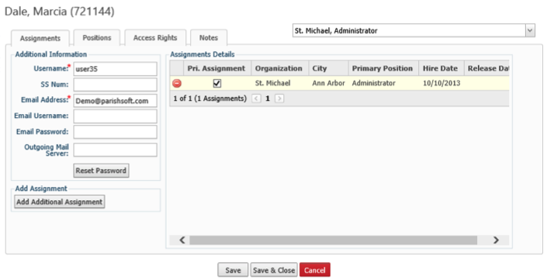
Assignments – To add user name and give password and to add assignments (for cluster parishes)

Click Edit Details
Click Add Additional Assignments (for staff needing access to more than one parish)
You will need to do an organization search to find the additional parish.
Once found click the circle next to the parish and click accept. Be sure the box is checked next to the main parish.

Put in the staff member’s username and e-mail address. Click reset password when all the information is in. The staff member will receive an e-mail with a temporary password that will need to be changed once they log into ConnectNow.
If a staff member lost their password this page is where you are able to reset their password. An e-mail will be sent to the employee with a temporary password.

Once completed click save and close.

Module Setting
This section is to change names of the modules to accommodate the names parishes use.
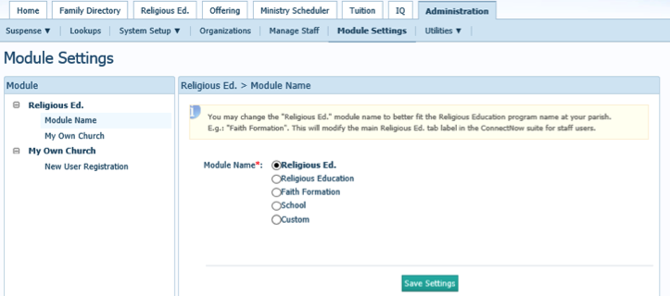

Additional Resources
Click the Help link in the upper right corner of the display to review help on the page you’re viewing, or search for help on whatever topic you need.
You can also access online help articles and videos by going to www.parishsoft.com/kb.

You may also want to sign up for additional Teletraining or Video classes. Just go to www.parishsoft.com/training for a complete list of the latest offerings.
If you would like to speak to a Support Team Member, please email us at support@parishsoft.com, or call 866-930-4774x2 Monday through Friday from 9am-7pm ET.

Teletraining Instructions
If you are taking any of the classes via Teletraining, please follow the instructions below:

- Please call in 10 minutes before class. If you are having difficulty connecting, we can help you in this time and not take up actual training time.
- Please introduce yourself with your Name, Parish Name and City, State as attendance will be taken.
- When the class begins, please mute your phone as background noise can be distracting for the other attendees. If you cannot find the mute button on your phone, use 6# for the phone bridge mute and 2# to increase the volume.
- Go to https://www.connectnow.parishsoft.com/training
- Log in with the username and password given to you by the ConnectNow trainer.
- Please note the ConnectNow display may look slightly different than the trainer’s display if using a different browser.

