ConnectNow
Offering Training Guide

Training Website:
http://connectnow.parishsoft.com/trainingdemo/

User Name: user__
Password: pass12
Live Website: https://connectnow.parishsoft.com/winona

Table of Contents
Offering 3
Funds 4
Add a Fund 6
Edit a Fund 6
Fund Permissions 7
Batches 8
Add a Batch 8
Close a Batch 9
Quick Reports 9
Posting 10
Posting Contributions in Batch 11
Contribution List 11
Correct a Contribution 13
Quick Reports 13
Giving History 11
View Giving History 14
Reports 11
Contribution Statement 15
Pledge Management 17
Pledge Management Overview 19
Pledge Batches 19
Pledge Management 19
Adding New Pledges 19
Pledge Record Fields 21
Create $0 Pledges 23
Edit a Pledge 24
How to Delete a Pledge 24
Posting to a Pledge 25
Pledge Reports 25
Pledge Statements 26
Pledge Detail Report 28
Offering
ConnectNow Offering is a software solution in the ConnectNow Family Suite that helps churches record and manage charitable contributions given to their organization by members and benefactors. The module handles both regular offerings and contributions made by pledge to specific funds and to capital campaigns. You can access your data from any device with an internet connection, and backups and updates are automatic.

Click the Offering tab 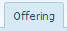 to access the Offering Module.

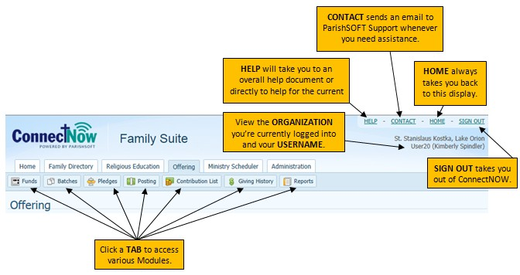
The Offering tab has seven buttons that give you the ability to access and manage family/member contribution and pledge transactions.
  - The Funds page lists all of your funds. You can add new funds, delete selected funds, and set permissions from this page.
  - The Batches page provides a list of all batches created, both open and closed. You can view, add and delete batches.
  - The Pledges page provides a central location for adding and managing pledge records.
  - From the Posting page you can post contributions and pledge payments to your donor records.
  - The Contribution List page lets you view contribution records for a particular day or a specified time period.
  - The Giving History page contains a list of all of the donors in your organization and enables you to link to their giving history records.
  - The Reports page gives you quick and easy access to your organization's contribution, pledge, and batch reports.

Funds
Click the Funds tab.
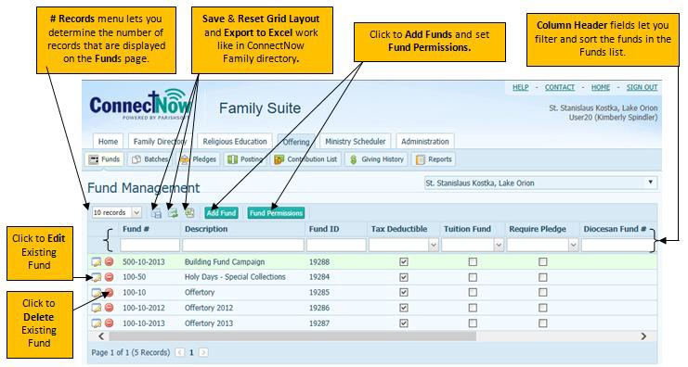

- Fund #’s use number characters (0-0) and my also include a dash (-) and are user defined. Fund #’s are set by the Diocese. If a full conversion was done then the original accounts were pulled into ConnectNow.
- Below is a list of Funds and fund numbers set up by the Diocese of Winona:
COA ID | Account | Description
1 | 8-00 | Offertory
2 | 10-00 | Holy Day
3 | 10-01 | All Saints
4 | 10-02 | All Souls
5 | 10-03 | Ascension
6 | 10-04 | Ash Wednesday
7 | 10-05 | Assumption of Mary
8 | 10-06 | Holy Thursday
9 | 10-07 | Immaculate Conception
10 | 10-08 | Mary Mother of God
11 | 10-09 | Palm Sunday
12 | 10-10 | Thanksgiving
13 | 10-11 | Envelope Loose
14 | 10-12 | Father’s Day
15 | 10-13 | Mothers Day
16 | 10-14 | Sacrificial Giving
17 | 10-15 | Christmas
18 | 10-16 | Easter
20 | 12-00 | Misc Parish Collection
21 | 13-00 | Christmas Flowers
22 | 13-01 | Christmas Memorial
23 | 13-02 | Easter Flowers
 | 5-00 | Adult Support
 | 5-01 | Stock Contribution
 | 15-00 | Diocesan Collections
 | 15-01 | Latin America
 | 15-02 | Catholic Communications
 | 15-03 | Aid Church in Eastern and Central Europe
 | 15-04 | Rice Bowl
 | 15-05 | Catholic Relief Services
 | 15-06 | Holy Land
 | 15-07 | Catholic Charities
 | 15-08 | Peter's Pence
 | 15-09 | Home Mission
 | 15-10 | Black / Native American
 | 15-11 | Propegation of Faith
 | 15-12 | Campaign for Human Development
 | 15-13 | Retirement Fund for Religious
 | 15-14 | Catholic University
 | 15-15 | Acrchdiocese for the Military Service
 | 15-16 | Pastoral Solidarity Fund for the Church in Africa
 | 15-17 | Missionary Cooperative Plan
 | 15-18 | Natural Disaster Assistance
 | 20-00 | Memorial
 | 25-00 | Building/Maintenance
 | 25-01 | Utilities
 | 30-00 | Religious Education
 | 35-00 | Courier
 | 40-00 | Charity
 | 45-00 | Cemetery Care
 | 50-00 | Catholic Ministries Appeal
 | 55-00 | Rooted in Faith
 | 60-00 | Seminarian Burse
 | 65-00 | Newman Center - Winona
 | 70-00 | Newman Center - Mankato
 | 75-00 | IHM Seminary

Add a Fund
Exercise: Add a Fund.
- Click the Add Fund button.

The fields with a red asterisk *, Fund # and Description are required fields; all other fields are optional.

- Enter Fund # 10-19-99, and Description of Festival.
- Click the Add Fund button at the bottom.
- Then confirm the Fund Details and click the Close button.

- Use the Start Date & End Date fields when you want to specify the period during which the fund accepts contributions.
- If the fund has an account number or ID in your diocesan accounting system, type that number in the Diocesan # field to facilitate references between your diocesan accounting system and the Offering application.
- If the fund has an account number or ID in an external system (for example, a QuickBooks account number), type that number in the External # field to facilitate integration of data from the external system into the Offering application.
- Check the Tax Deductible box if contributions to the fund are tax deductible (Tax deductible funds are included in charitable giving statements).
- Check the Require Pledge box to designate the fund as pledge based. If you check this box, all contributions posted to the fund must be in the form of a pledge.
- Check the Tuition Fund box if the fund is tuition fund. If this box is checked, the fund can be accessed by users with Tuition fund permissions.
- Check the Enable Import if you want imported data to update this fund.

Edit a Fund

ConnectNow Family Directory Training Guide
Exercise: Edit an existing Fund.
Click the Edit button next to Holy Days Special Collections. The Fund Details box opens.
- Click the Edit button.
- Change the description from “Holy Days - Special Collections” to “Holy Days” and
- Click the Save button.
- The Details Screen comes back up so you can verify and click Edit if further changes are needed. Click Close.

Fund Permissions
- Click the Fund Permissions button. The Manage Fund Permissions detail box opens.
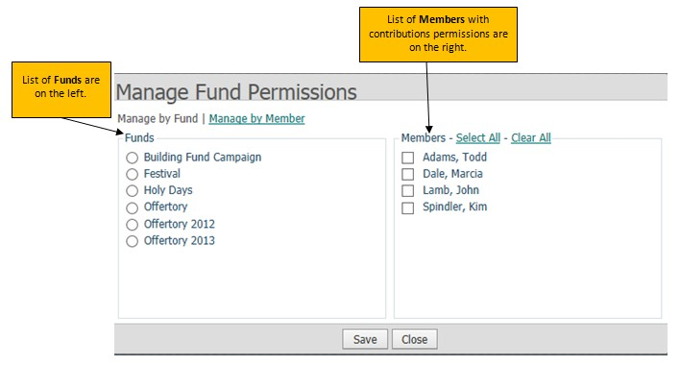

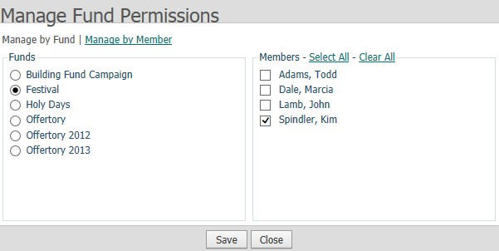
- Select the Festival fund by clicking the circle button to the left of the fund name.
This brings up a list of members on the right, with the member who created the fund checked as well as any Parish Administrators checked.
- Click Select All to give permissions to all members for this fund.
- Click Save and then OK on the message box for Permissions saved.
- Now select Manage by Member, notice how the layout changes. The list of Members is now on the left and the list of Funds on the right. Click the circle button next to the first member in the list to view/edit the funds they have permissions for. Click Close.

Batches
Click the Batches tab.
Using batches to enter your contribution data is not required but highly recommended. Batch processing is particularly useful if you have a number of contributions, pledges, or corrections to post. Processing transactions in batches can save you a lot time because you can enter them into the system in groups instead of entering them one at a time. Batch processing also provides controls and greater safeguards against fraudulent actions.
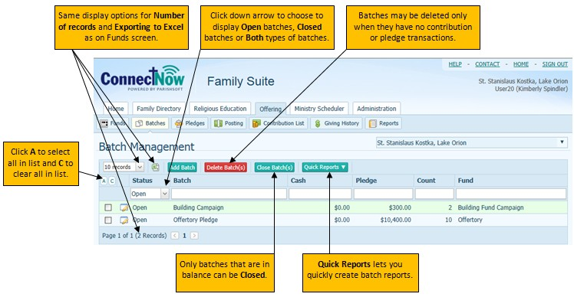

Add a Batch
Exercise: Add a new Batch.
- Click Add Batch button. Create new batch message box opens.
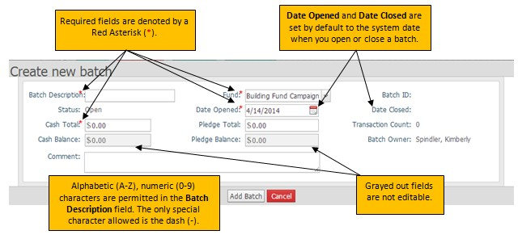
- Enter a Batch Description of 9 AM and the date of last Sunday
(This field will only accept letters (a-z), numbers (0-9) and dashes (-). Make sure to use a dash instead of a slash when entering a date.)
- Select Fund Offertory 2013
- Leave the Date Opened as today’s date
- Set Cash Total to 177.63
- Leave the Pledge Total and Comment blank
- Click Add Batch
You can now review the batch details you just entered and Edit the batch details if needed.
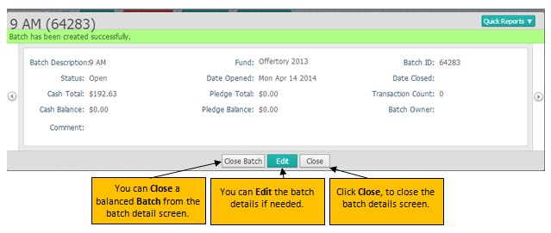
- Click Close.

Close a Batch
There are two ways to close a Batch.

Method #1: You can check the box to the left of the desired batch on the Batch Management screen and then click the Close Batch(s) button in the toolbar.
Method #2: You can click the Edit icon to the right of the desired batch; edit the batch details, Save and Close Batch.
Use Method #1 if you know the batch is in balance and do not need to edit the batch details. Use Method #2 if you need to verify the batch is in balance or edit the batch details.
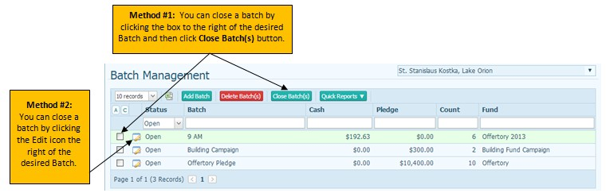
Note: Once a batch is closed is cannot be reopened.

Quick Reports
Reports can be pulled to view batch list and batch detail.
Posting
Exercise: Enter contributions to post.
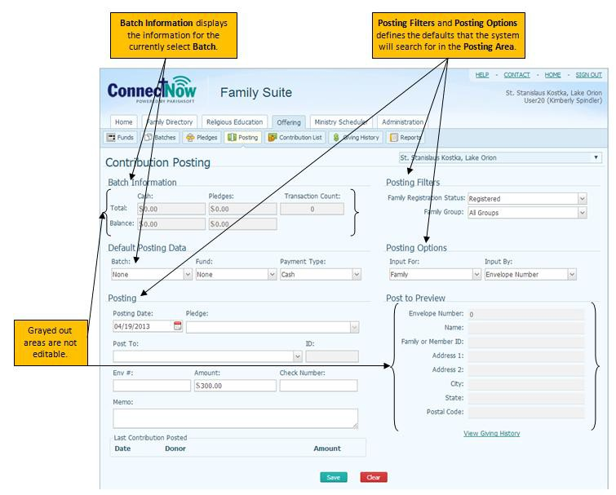
Click the Posting tab.

The Posting section is where you enter information about the contribution(s) you are posting.
  - The Posting Filters section selects the default registration status of the families the system will search for in the Posting Area.
    - Family Registration Status: select the registration status of the records you want to work with.
    - Family Group: select the family group to use as a filter.

Selecting posting filters can improve system performance. However, if you want to make sure that you include everyone, we recommend that you set Family Registration Status to Both and Family Group to All.
  - The Default Posting Data section provides a quick way for you to set the defaults for data that you enter sequentially (into the same batch and fund and with the same payment type).
    - Batch: if you are posting contributions in a batch, select the name of the batch from the list. If you are not posting by batch, select None. Only open batches are shown in this list. The system will default to the last batch used when opening this page.
    - Fund: the contribution must be associated with a fund. Select the fund you are posting the contributions to.
    - Payment Type: select the payment method.

  - The Posting Options section defines the method you will use to input the contributions:
    - Input For: select the setting that matches how your postings are sorted (for example, if organized by family, select Family).
    - Input By: select the field you want to use to identify contributors (for example, if you are entering contributions by the donor's last name, select Name).
Your filter settings remain in effect until you change them for the next group. You can now post the group of contributions matching your filter selections into the system.
- Posting Date: the date the contribution was received by your organization.
- Pledge: if the contribution is in pledge form, select the pledge the contribution is associated with from the list. (This will be covered in Pledges)
- Post To: this search field is associated with the option selected from the Input By dropdown list in the Posting Options section. For example, if Input By is set to Name, type the first few letters of the name of the donor you are searching for in this field. If Input By is set to Envelope Number, type the envelope number of the donor you are searching for in this field.
- ID: Family DUID of the selected donor.
- Env #: Donor's envelope number.
- Amount: dollar amount of the contribution.
- Check Number: check number if the payment was made by check.
- Memo: this field lets you record notes related to the transaction you are posting.

Posting Contributions in Batch
Exercise: Posting Contributions in a Batch
- Set the Default Posting Data
  - Select the Batch just created of 9 AM (and date of last Sunday)
  - Confirm that the Fund is Offertory 2013 and Payment Type is Cash

Set the Posting Filters
  - Family Registration Status to Both
  - Family Group to All Groups
- Set the Posting Options
  - Leave Input For at Family and Input By at Envelope Number.

Posting
  - Change Posting Date to last Sunday’s date
  - Leave Pledge blank
  - Post To:
- Enter Envelope # 1129, then tab
  - Post to Preview Section displays Todd and Jane Adams
- Enter Amount: 10.00; tab
- Check Number: None; tab
- Memo – leave blank
- Click Save
  - Notice that the Balance in the Batch Information is reduced by $10.00
  - Post To:
- Envelope #: 5317 (Cathleen Rigden)
- Amount: 80.00
- Check Number: 4553
- Memo: Blank

Save
  - Post To: (One check from a family for 2 funds)
- Envelope #: 884 (Eric and Rebecca Mueller)
- Amount: 30.00

Check Number: 525
- Memo: Blank

Save
  - Post To:
- Change the Fund in the Default Posting Data to the

Building Fund Campaign.
- Envelope #: 884 (Eric and Rebecca Mueller)
- Amount: 20.00
- Check Number: None
- Memo: Blank

Save
  - Post To:
- Change the Posting Option, Input By to Last Name
- Change the Default Posting Data, Batch to Offering 2013
- Type in Loose in the Post To field
  - Select Cash Loose
- Amount: 37.63
- Check Number: None
- Memo: Blank

Save

Contribution List
Click the Contribution List tab.
The Contribution List page lets you view contribution records for a particular day or a specified time period. From this page you can edit or delete a previously posted contribution record as long as the batch containing the record is open.
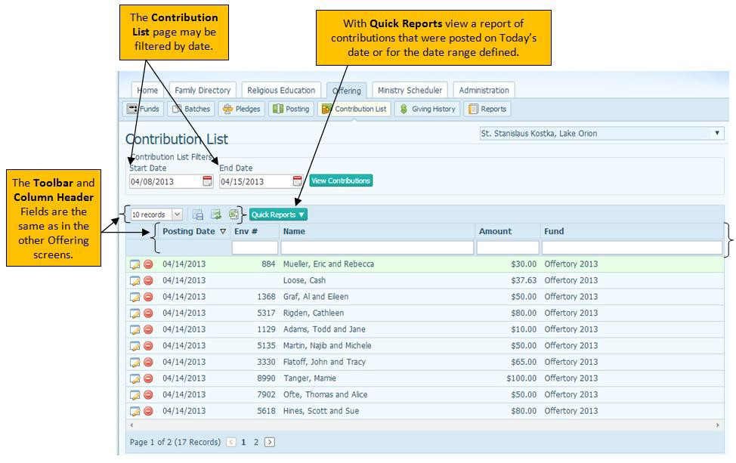

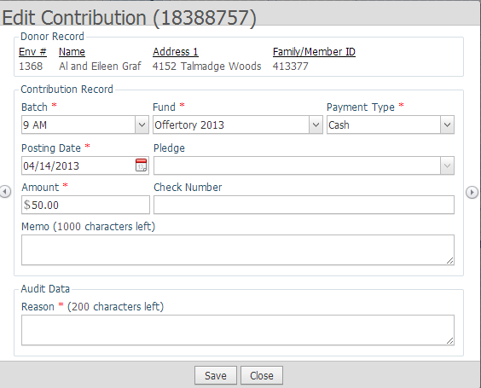
Correct a Contribution
- Click the Edit icon next to the $50.00 Offertory 2013 contribution for Env #1368.
- Change Amount from $50.00 to $15.00.
- In the Reason box, enter “Corrected Amount”.
Note: For auditing purposes, you must supply a reason for any changes you make to a record.
- Click Save, then Close to exit after the Contribution record updated message box appears.

Quick Reports
Reports can be pulled to view batch list and batch detail.

Giving History
Click the Giving History tab.
The Giving History page contains a list of all of the donors in your organization. This page gives you at-a-glance information for each donor: the family DUID, email address, and primary telephone number. Each name in the list is a link to the donor's giving history. Clicking the link directs you to the named donor's giving history where you can view all of the funds the donor has pledged and contributed to, the exact dates of giving, and giving amounts.
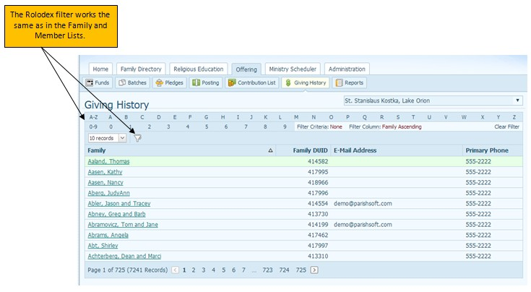

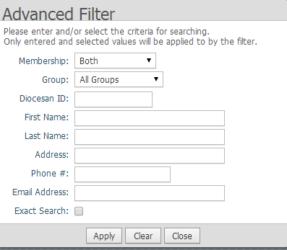

View Giving History
Exercise: View Giving History
Click on “G” in the Rolodex filter.
Click on the Filter icon in the toolbar.
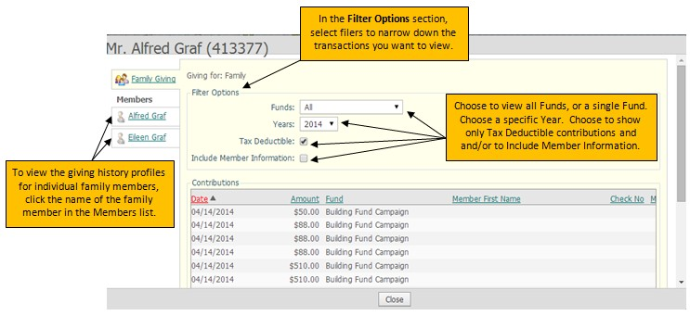
Change the Year to 2013.

Click Close.

Reports
Click the Reports tab.
The Reports page gives you quick and easy access to your organization's contribution, pledge, and batch reports. Reports are classified in 4 types: Contributions, Pledges, Batches and Audit. Reports are then broken down by each type as follows:
Contributions
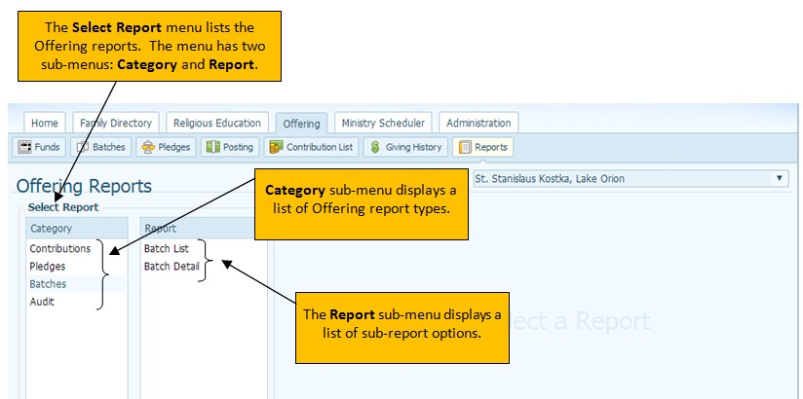
- Contribution Statements
- Postings
Pledges
- Pledge Statements
- Pledge Detail
Batches
- Batch List
- Batch Detail
Audit
- By User
- By Type

Contribution Statement
Exercise: Create Contribution Statements for any donor in your organization who has given more than $250.00.
  - In the Select Report, Category sub-menu click on Contributions.
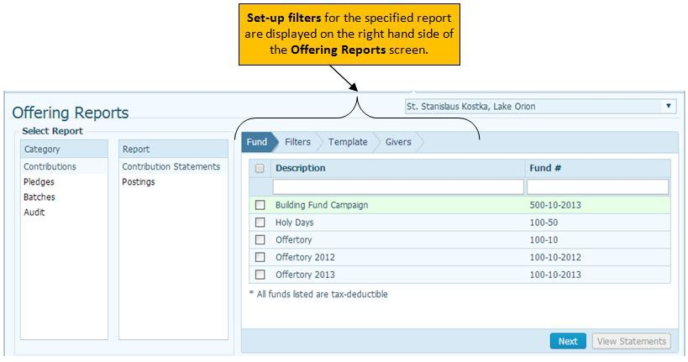
  - In the Select Report, Report sub-menu click on Contribution Statements.
  - Click the box next to Description to select all funds, and then click Next.

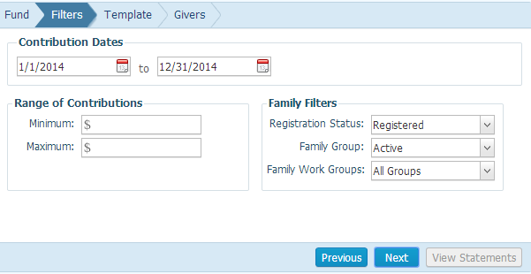
  - In Range of Contributions type 250.00 in the Minimum field.

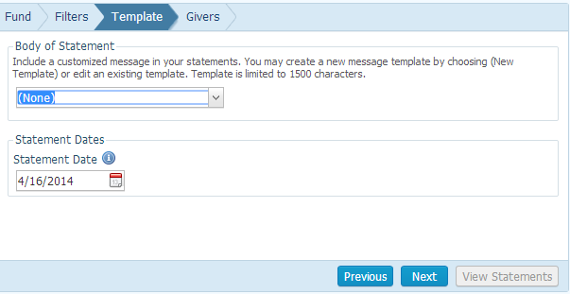
  - In Family Filters select Registration Status of Both, Family Group of All Groups and Family Work Group of All Groups, click next.
  - In the Body of Statement select New Template in the drop down.

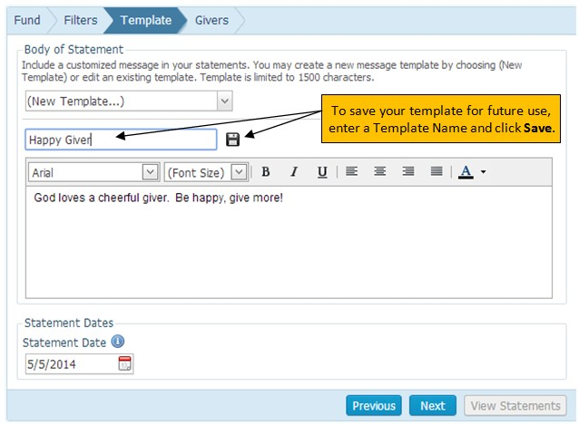

  - In the Body of the Template, type “God loves a cheerful giver. Be happy, give more!”
  - The type Happy Giver in the template name field
  - Click the save icon
  - Leave the Statement Date
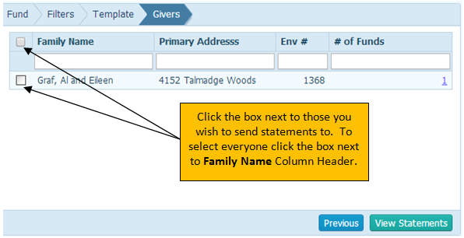
for today, and click Next.

  - Check the box to the left of Graf, Al and Eileen.
  - Click View Statements .
  - T o close the Statement Report window, click the red X in the upper right hand corner of the window.

Pledge Management
Pledge Management Overview
Pledge Management provides a central location for managing your organization's pledge records, viewing pledge details, and tracking payments on a pledge. Authorized users can:
  - Find existing pledges and view pledge details
  - Add a new pledge
  - Create zero dollar ($0) pledges
  - Edit a pledge
  - Delete a pledge
  - Post to a pledge
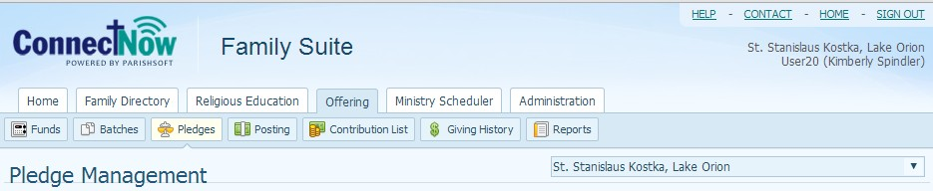

Pledge Batches
If you are entering pledges into the system, it is recommended that you first create a batch. When you later add pledges to a fund, you are prompted to select the batch you created. By creating pledge batches you can easily track of the receipt of all pledges and along with any pledge down payments.

Exercise: Create a Batch for Pledges.
From the ConnectNow Offering tab, click Batches
From the Batch Management page, click Add Batch
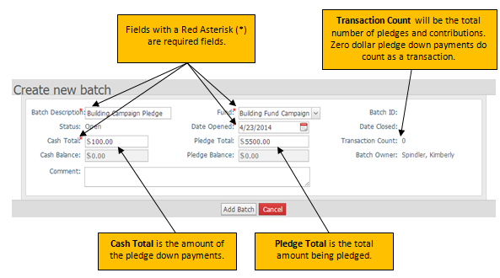
- Type Building Campaign Pledge in the Batch Description
- Select the Fund Building Fund Campaign
- Leave the Date Opened set to today
- Set the Cash Total to 100.00
- Set the Pledge Total to 5500.00
- Leave the Comment field blank (Comments can be added later if desired)
- Click Add Batch
- When the Batch has been created successfully window appears click Close

Pledge Management

Click the Pledges button from the ConnectNow Offering Tab.
A pledge is an amount that a donor promises to give to a fund. After you add a pledge record, you can post payments to the pledge.
The pledge list shows you all of the records for the selected fund. You can view pledge details and track payments for a pledge.

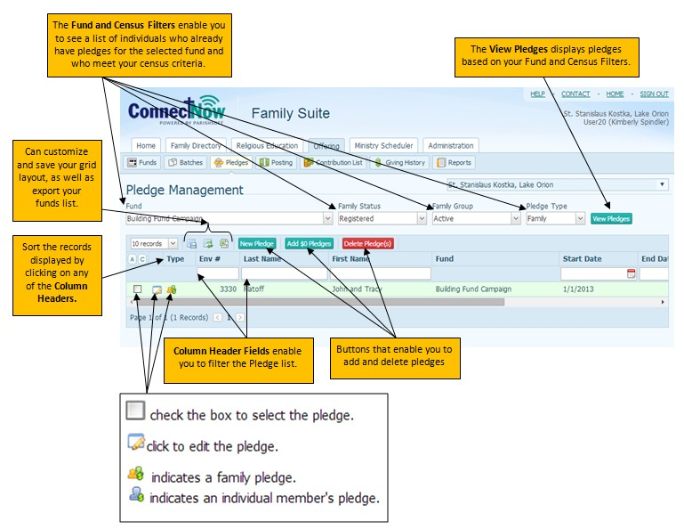

Adding New Pledges
Exercise: Add a new Pledge.
  - From the Pledge Management screen change the Fund to Building Campaign Fund
  - Leave Family Status as Registered; Family Group as Active and Pledge Type as Family
  - Click View Pledges button
  - Then Click New Pledge button

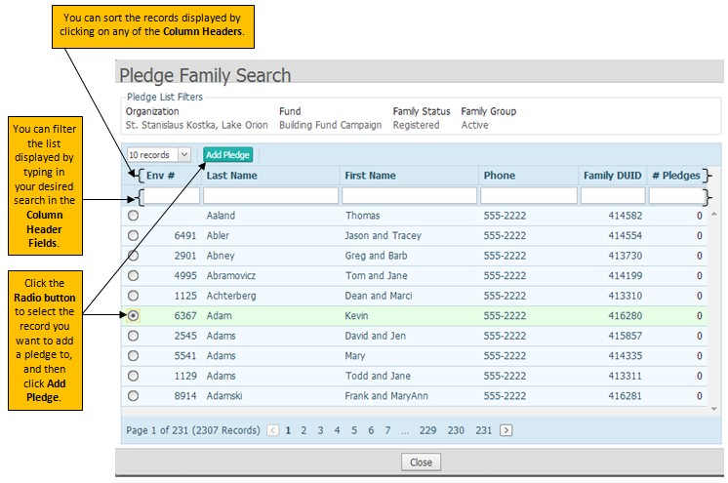
  - Enter envelope number 5618 in the Env # Column Header Field
  - Click the Circle Button next to the record for Hines, Scott and Sue
  - Click Add Pledge

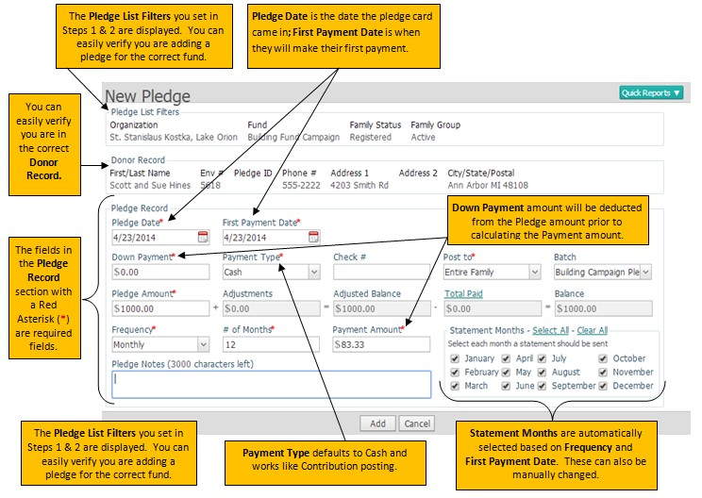

  - Click the Calendar Icon next to Pledge Date and change it to today’s date.
  - Tab to First Payment Date, click the Calendar Icon and change it to today’s date.
  - Tab to Down Payment, leave it as $0.00
  - Tab to Payment Type, leave it at the default setting of Cash
  - Tab to Check #, leave it blank
  - Tab to Post to, leave it as the default setting of Entire Family
  - Tab to Batch, verify it is set to Building Campaign Pledge
  - Tab to Pledge Amount, type 1000.00

Notice the next 4 fields are inactive, as they either are calculated fields or information can’t be entered until the pledge is saved.
  - Tab to Frequency, select Monthly
  - Tab to # of Months, type 12. (Length of pledge in months, no matter the frequency) Notice the Payment Amount automatically calculated, along with the populating of the Statement Months.
  - Statement Months: Leave as default
  - Leave Pledge Notes: Blank
  - Click Add, then Click OK on the Pledge record created message box and then Close

It is not necessary to tab through each field if not all are needed. You can click into the fields needed instead.

Pledge Record Fields
Below is more information on each field as you enter pledges.
Field | Description
Pledge Date* | Date the pledge was received. This field defaults to the date from the last saved pledge. If no previous pledges are made to this fund, the field defaults to today's date.  Click and select the date. Alternatively, you can enter the date in mm/dd/yyyy format.
First Payment Date* | Date the first payment toward the pledge will be made. This field defaults to the date from the last saved pledge. If no previous pledges are made to this fund, the field defaults to today's date.  Click and select the date. Alternatively, you can enter the date in mm/dd/yyyy format. The date you select must be greater than or equal to the pledge date.
Down Payment* | Down payment amount.  Type the amount of the donor's down payment in this field.
Payment Type* | Means of payment used by the donor. Select one of the following: Cash (includes cash and checks), Credit, Matching Gifts, Soft Gifts, or Stock Gifts.
Check # | Check number if the pledge payment was made by check. Type the check number in this field.
Post to* | Name of family member to attribute the pledge to. Select family (the default) or the name of the family member from the dropdown list.
Batch | Batch containing the pledge.  Select the batch from the dropdown list. Only open batches are shown in the list.
Pledge Amount* | Total amount of the pledge.  Type the pledge amount in this field. This field accepts a negative value.
Adjustments | Read-only field. If any adjustments were made to the pledge, the system shows you the adjustment amount.
Adjusted Balance | Read-only field. The system calculates this value, which is equal to the pledge balance plus any adjustment amount.
Total Paid | Read-only field. The total amount paid to date toward the pledge amount. The system calculates this value. Click Total Paid to view the donor's pledge payment history.
Balance | Read-only field. Balance owed on the pledge.
Frequency* | Payment frequency. Select an option to indicate how often the donor wants to make payments.
# of Months* | Length of pledge period in months. Type the number of months in this field.
Payment Amount* | Payment amount after the down payment is applied.
Statement Months | Check the months in which the donor would like to receive a statement. If the donor wants to receive a statement every month, click Select All. If the donor does not want a statement sent each month, select Clear All.
Pledge Notes | You can provide information that you want to store with the pledge. You can use this field to track reasons for any adjustments made to the pledge.

Exercise: Create a pledge with a down payment and 6 months in length
- Click New Pledge
- Enter envelope number 1368 in the Env # Column Header Field
- Select Graf, Al and Eileen
- Click Add Pledge
- Pledge Date: Today
- First Payment Date: First of next month
- Down Payment: 100.00
- Payment Type: Cash

Check #: Blank
- Post to: Entire family
- Batch: Building Campaign Pledge
- Pledge Amount: 700.00
- Frequency: Monthly
- # of Months: 6
Notice the payment amount of $100.00
- Statement Months: Deselect the months outside of the next 6 month period
- Pledge Notes: Blank
- Click Add, then Click OK on the Pledge record created message box and then Close.

Exercise: Create a One-Time Pledge
- Click New Pledge
- Enter envelope number 7902 in the Env # Column Header Field
- Select Ofte, Thomas and Alice
- Click Add Pledge
- Pledge Date: Today
- First Payment Date: Today
- Down Payment: None
- Payment Type: Cash

Check #: Blank
- Post to: Entire family
- Batch: Building Campaign Pledge
- Pledge Amount: 100.00
- Frequency: One Time
- # of Months: 1
- Statement Months: Leave as default
Notice the only month selected in the Statement Months is this month
- Pledge Notes: Blank
- Click Add, then Click OK on the Pledge record created message box and then Close.

Exercise: Create a second pledge for a family.
- Click New Pledge
- Enter envelope number 3330 n the Env # Column Header Field
- Select Flatoff, Todd and Jane
- Click Add Pledge
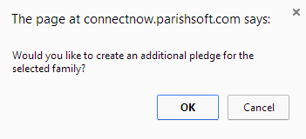
  - Notice the message box that is displayed, click OK
- Pledge Date: Today
- First Payment Date: Today
- Down Payment: None
- Payment Type: Cash

Check #: Blank
- Post to: Entire family

Creating $0 Pledges
Use the Add $0 Pledges procedure to create zero dollar ($0) pledges or empty pledge records for a fund. Use this method as a shortcut for your church-wide pledge campaigns so that you do not have to search your database one family at a time and then create a pledge record for each individual family.
To add zero dollar pledges, you must have permission to access the fund to which you are adding the pledge and View plus Add/Edit access rights tied to your login credentials.

The following procedure lets you generate a pledge record of $0 for each family in your database that does not already have a pledge for the selected fund. As you receive pledge cards from the families for which you have created $0 pledges, you can quickly record the actual pledge amounts and payment schedules.
- If you manage several organizations, select the desired organization from the Organization list.
- Click to display the Pledge Management page.
- Select filters to create a subset of pledge records to work with. Then, click .
- Click .

The Add $0 Pledges window is displayed.

Zero dollar pledges are created only for those families that match your filter criteria, which are displayed for you in the window. For example, as the previous illustration shows, zero pledge records will be created for all active registered families who do not currently have a pledge record for the Air Conditioning fund.
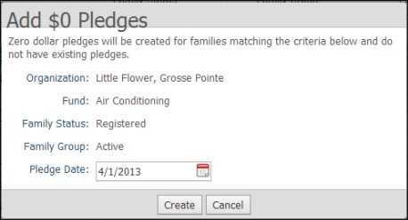
- Verify your filter criteria.
- Click the Calendar Icon and specify a date for the $0 pledges.
- To create the pledges, click .
- A message is displayed asking you to confirm your request.
- Click to begin the process.
The application searches your database to locate families who meet your filter criteria. The application ignores families who already have a pledge record in your database and will not add a $0 pledge record for that family. Depending on the number of records, the process can take several minutes. After the process is completed, a message is displayed informing you of the number of zero dollar pledges the application created. Click to dismiss the message. Your pledge list is updated. You return to the Pledge Management page.
Families who do not end up making a pledge continue to show in your records with a $0 pledge. If you want, you can delete these pledges from the fund.

Edit a Pledge
If you need to make an adjustment to an existing pledge (for example, change the pledge amount, payment schedule, or a payment type), use this procedure. The system automatically recalculates balances and payments for you. Any adjustments you make are reflected in the balance due amount in the family's pledge record and in pledge reports, such as statements and projections. Note that you cannot edit pledges that are in a closed batch.
To edit a pledge, you must have View plus Add/Edit access rights for Contributions assigned to your login credentials.
  - If you manage several organizations, select the desired organization from the Organization list.
  - Click to display the Pledge Management page.
  - Locate the donor whose pledge you want to adjust. You can do this by typing the donor's envelope number in one of the column header fields (for example, type the envelope number in the Env# field or the last name in the Last Name field).
  - Click next to the donor's name.
The Edit Pledge window for the selected donor is displayed.
The donor's personal information is displayed at the top of the form. This information is pulled from the family record.
The editable fields in the pledge record are located in the lower half of the window. The fields shaded in gray, however, cannot be changed. The application automatically calculates the amounts in these fields based on the pledge amount and posted payments and adjustments.
  - Edit the pledge details as necessary. See Pledge Record Fields for descriptions of the editable fields in the Pledge Record portion of the form.
  - Click .
A message is displayed to inform you that the pledge record was updated with your changes.

How to Delete a Pledge
  - If you manage several organizations, select the desired organization from the Organization list.
  - Click to display the Pledge Management page.
  - Use the filters to find the pledges that you want to delete.
  - Check the box for each pledge. Then, click . You are prompted to confirm the deletion.
This button is disabled (dimmed) if you do not have Delete permission.

  - Do one of the following:
  - Click to delete the selected pledges.
  - Click to exit the procedure without deleting the selected pledges.

Posting to a Pledge
Exercise: Posting to a pledge
- Click on the Posting Icon
- Set your Default Posting Data, Posting Filters and Posting Options
  - Batch: Building Campaign
  - Fund: Building Fund Campaign
  - Payment Type: Cash
  - Family Registrations Status: Both
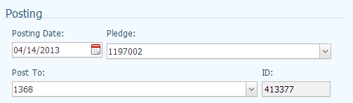
  - Family Group: All Groups
  - Input For: Family
  - Input By: Envelope Number
- Set your Posting Date to today
- Post To: Envelope # 1368
Notice after the envelope is selected the pledge show in the Pledge field.
5. Amount: $100.00
6. Memo: Blank
7. Save

Exercise: Posting to a pledge when multiple pledges exist

- Leave your Fund and Date the same
- Post To: Envelope # 3330
- Click the Pledge drop down to select the correct pledge, choose the 1st one listed.
- Amount: $50.00
- Memo: Blank
- Save
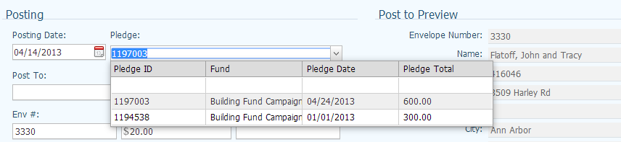

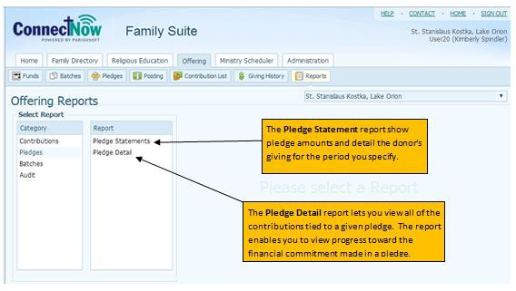
Pledge Reports
From the ConnectNow Offerings Tab, click on the Reports button, and then select Pledges in the Select Report: Category box.

Pledge Statements
Select Pledge Statements in the Select Reports: Reports box
The Pledge Statement report is presented in an easy-to-use, wizard-style interface that steps you through the process of creating your pledge statements.
To advance through the setup, you can either click the tabs at the top right or click in the lower right. At any time, you can click a tab or to return to a tab to view or make changes to previously entered information.

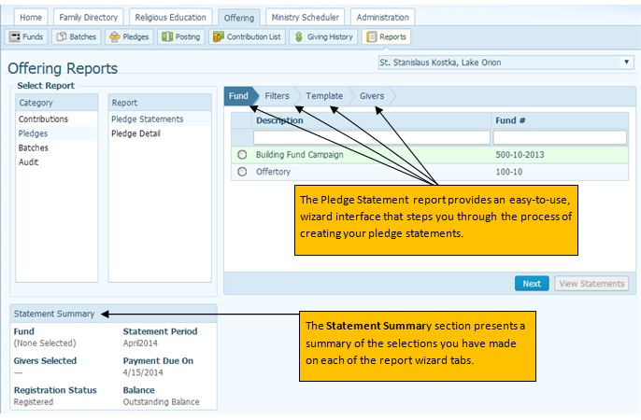
Exercise: Create Pledge Statements
- Select the Circle Button to the left of Build Fund Campaign
Notice how the Statement Summary changes in the lower left hand corner.
- Click Next
- Statement Period Date: Current Month
- Family Filters: Registered, Active and All Groups
- Pledge Filters: Select 1st option “View statements scheduled in”
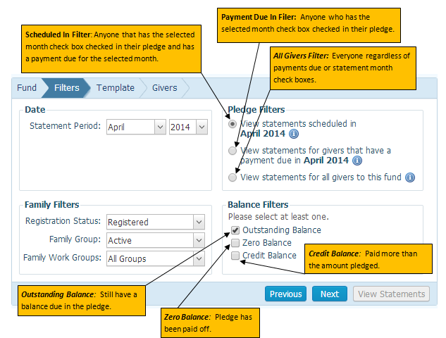
- Balance Filters: Outstanding Balance

- Click Next

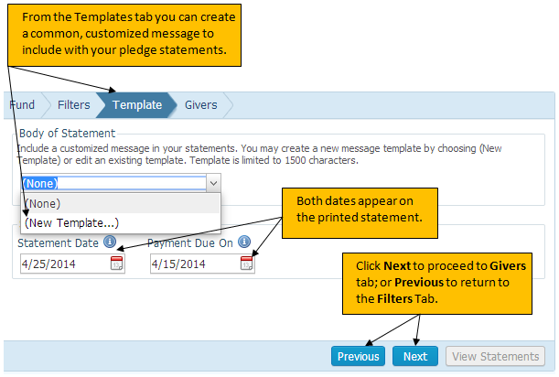

- Select New Template

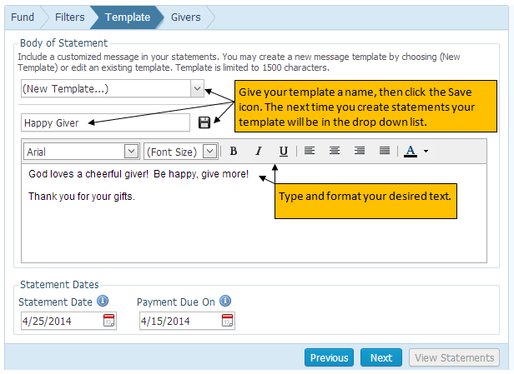

- Type “God loves a cheerful give! Be happy, give more! Thank you for your gifts.” in the message area.
- Type Happy Giver for the template name, and click the Save and then OK icon to save your template.
- Click Next

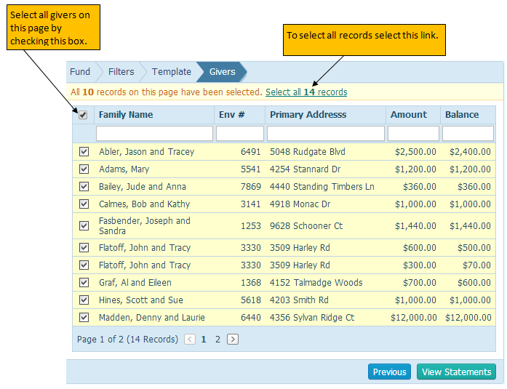
- Check the box to the left of the Family Name Column Header to select all of records displayed on the page, then click View Statements.
- Statements open in new window
- Each Statement is on a new page
- Each statement contains
- Parish name and address, statement date, giver mailing information, salutation, statement message, pledge details, and a coupon section
- Close the report window by clicking on the red “X” in the upper right hand corner of the window

Pledge Detail Report
The Pledge Detail report lets you view all of the contributions tied to a given pledge. The report enables you to view progress toward the financial commitment made in a pledge.

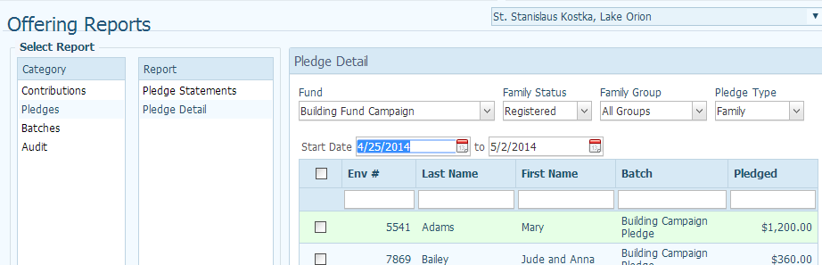

Exercise: Create Pledge Detail report
- Select Pledge Detail report from the Select Report: Report box.
- In the Pledge Detail report filter Fund drop down box, select Building Fund Campaign
- Family Status: Registered
- Family Group: All Groups
- Pledge Type: Family
- Set the date filer to include today
- Check the box to the left of the first name on the list, and then click View Report
- Report opens in new window
- Close the report window by clicking on the red “X” in the upper right hand corner of the window

