CN Family Suite Accounting Integration
The accounting integration allows you to connect their ConnectNow Family Suite database to their ConnectNow Accounting database. This prevents you from having to do double entry of offering information. This functionality can only be utilized if you use both ParishSOFT ConnectNow Family Suite, Parishsoft ConnectNow Accounting. There are 3 major steps to this process: 1. Integrating the databases at the Parent organization level or the Individual organization level. 2. Enabling a users’ permissions. 3. Mappings your funds and your batches.

Organization Integration
Before you can enable a users' permissions you must integrate the databases. To do this you must have administrative permissions.
- Login as organization administrator and navigate to Administration > Organizations.
- Select organization from list and click Edit Organization Record.
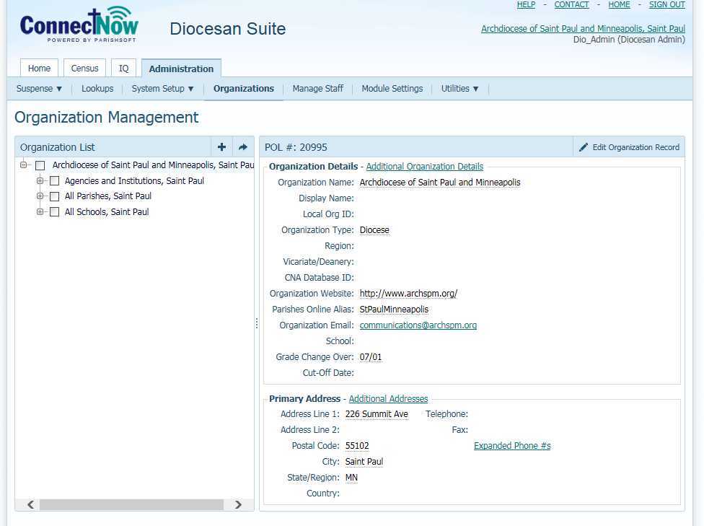
Enter CNA Database ID and click “Save”. If you do not know your ConnectNow Accounting Database ID please contact ParishSOFT Support.
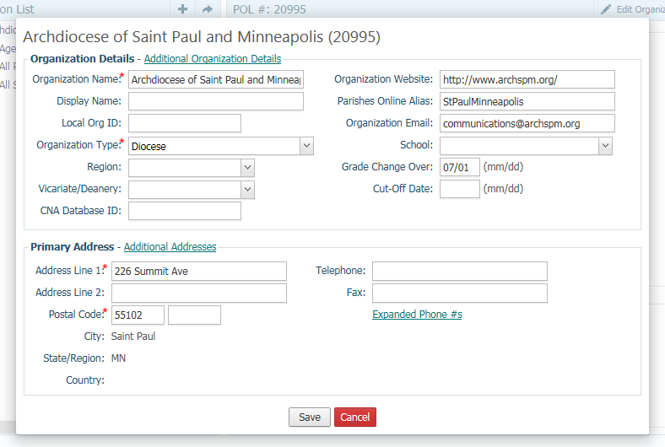
At this point, the CN Membership and CN Accounting applications are integrated at the organization level.

Enabling User Permissions
Login as an administrator and navigate to Administration > Manage Staff.
Select a staff record to open the assignment access rights.
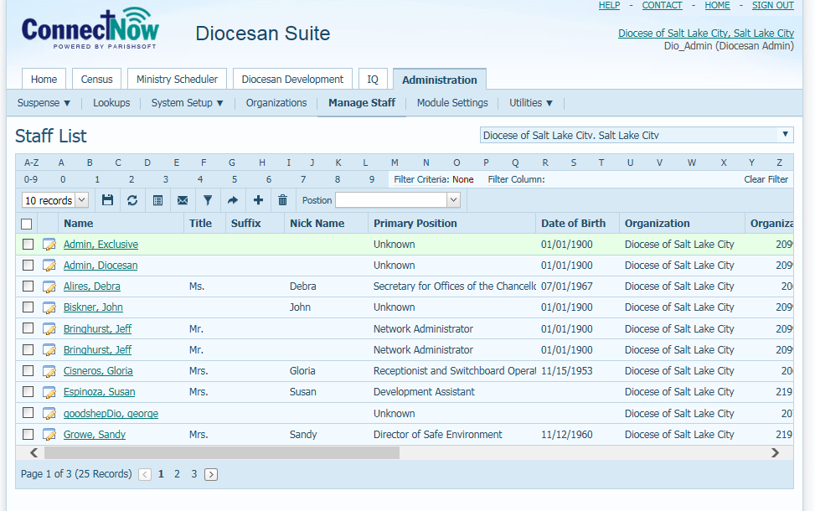
Click “Edit Details,” check the Offering checkbox in the Accounting Integration section, and click the gear icon.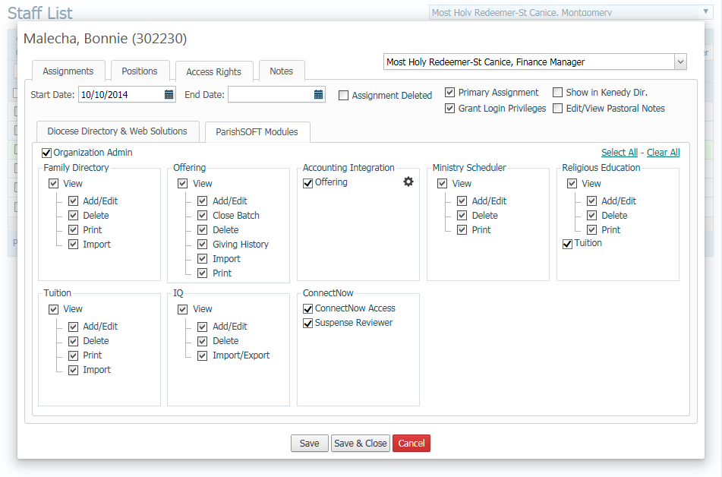

Enter accounting credentials (if known), and click “Login”.
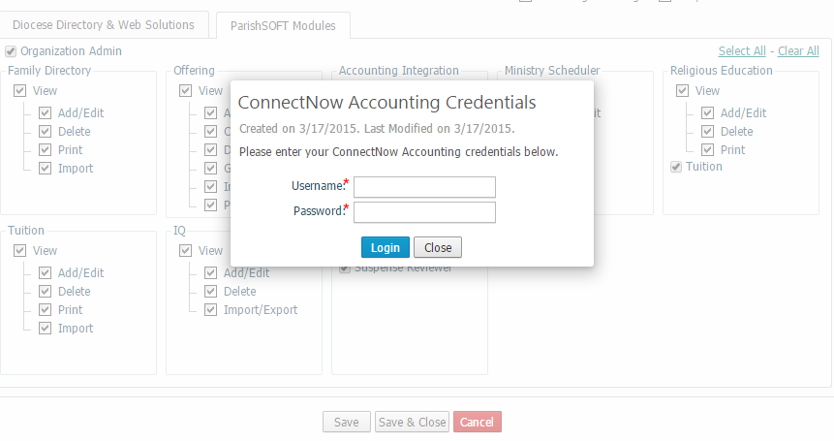
If credentials must be entered by a staff member without Administrative privileges, login and navigate to Offering > Settings. Enter accounting credentials and click “Save” (this will save a record in Offering.Integration.Credentials).
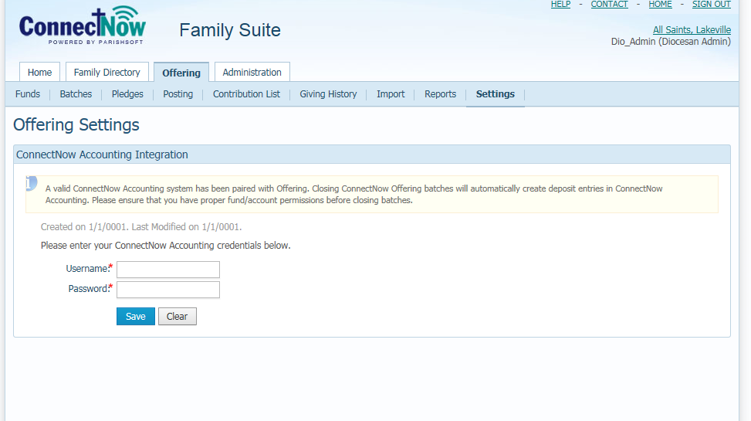
At this point, the CN Membership user is now integrated with the CN Accounting user.

Fund & Batch Mapping
Fund Mapping
The next step is to map your funds. This only needs to be done when there is a change to your ConnectNow Accounting Chart of Accounts, or when you are adding or editing funds in ConnectNow Offering. There is a one-to-one or a one-to-many relationship Fund to Revenue Account. You can have multiple funds in ConnectNow Family Suite associated or mapped to one revenue account in CN Accounting, or one fund mapped to one revenue account.
Family Suite Funds
Accounting Revenue Accounts
Integration Fund to Revenue Account Relationships

In the Offering Module, click on “Funds”. For pre-existing funds, select a fund with “Edit Fund” button.
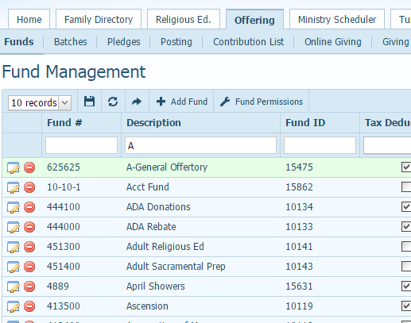

Click “Edit”
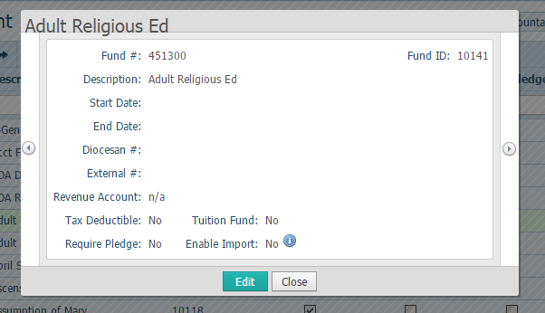
Then select a “Revenue Account” from the drop down menu, and click “Save”.
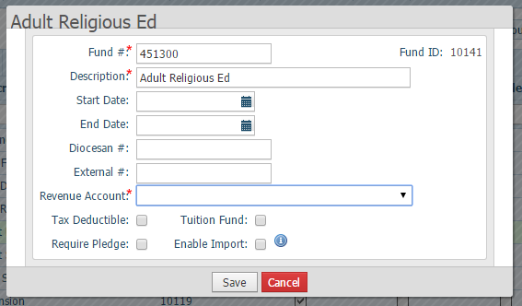

Batch Mapping
When ConnectNow Family Suite is integrated with ConnectNow Accounting one “Batch” in the Family Suite is Equal to one deposit in Accounting. This means that there is a one-to-one relationship, batch-to-bank account. This process is done for every batch you create. It can be done when the batch is created, or just prior to closing a batch.
In the Offering Module click on “Batches,” for a pre-existing batch select a batch by clicking on the “Edit Batch” Button.
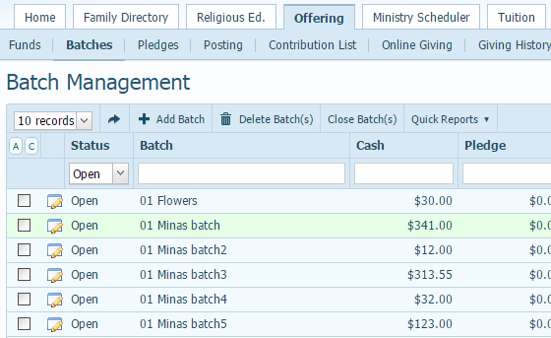

Click “Edit”
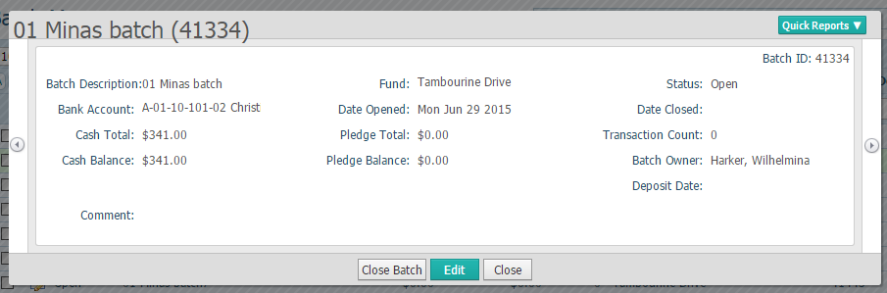
Select a “Bank Account” from the drop down menu, and click “Save”
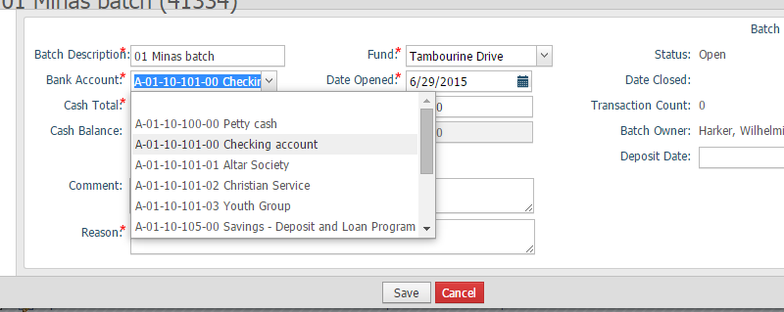
Click “Close”

