## 



Vatican II, *Gaudium et Spes* (#4); Pope Francis, *Evangelii Gaudium* (#14,51,108); and USCCB, “Living as Missionary Disciples.”

**Bishop Quinn’s episcopal motto is   
“Rejoice in hope.”** As servant leaders in our   
diocese, in good times and bad, we want and   
need to live out that joy of the Risen Lord.   
We also want and need to be able to “give a   
reason for our hope” (1 Pet 3:15).

Jesus Christ and his presence and work in southern Minnesota is our solid and eternal reason for hope. Yet there is no doubt that reading “the signs of the times” (Matthew 16:3) brings us locally unprecedented challenges to ministry: the fallout of abuse crisis, the bankruptcy, increasing political fraction and instability, attacks against life and dignity of the person and the human family on every front, the religious exodus of our younger generations, and a consumer mentality that redefines the human and becomes a warped lens for what it means to be Church.

Encouraged by the Second Vatican Council, the Holy Father, and the bishops of the United States to read these local signs of the times in the light of the gospel of God, we are called to press in to the joy of the gospel that comes from the Lord’s resurrection through the Holy Spirit. The Lord raises saints for every age, and every nascent saint receives this mission from the Lord:

**Introduction**

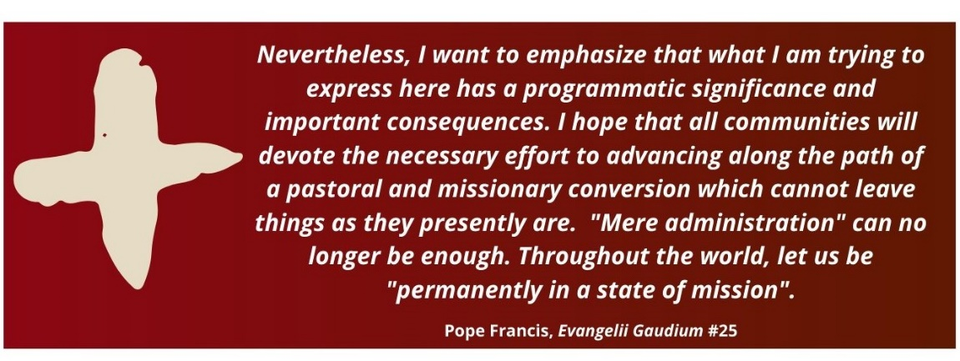

The structure and content that follow are based on the work of the United States Conference of Catholic Bishops in their document, “Living as Missionary Disciples: A Resource for Evangelization.”

“All power in heaven and on earth has been given to me. Go, therefore, and make disciples of all nations, baptizing them in the name of the Father, and of the Son, and of the holy Spirit, teaching them to observe all that I have commanded you. And behold, I am with you always, until the end of the age.” (Mt 28:18-20)

The universal call to holiness (*Lumen Gentium*, ch. 5) constantly encourages each of us to assess our own lives in Christ, and strive to depend more deeply on the Lord. But it also calls us to assess how our work in the diocese, and the relationships with those with whom we work and serve, are in alignment with this first and foremost mission to make disciples.

These guiding principles are offered to spur questions, conversation, prayer, and action in our own relationships of ministry regarding how we, together, move the Diocese of Winona-Rochester from maintenance of structures and buildings to mission first.

**Missionary Discipleship**

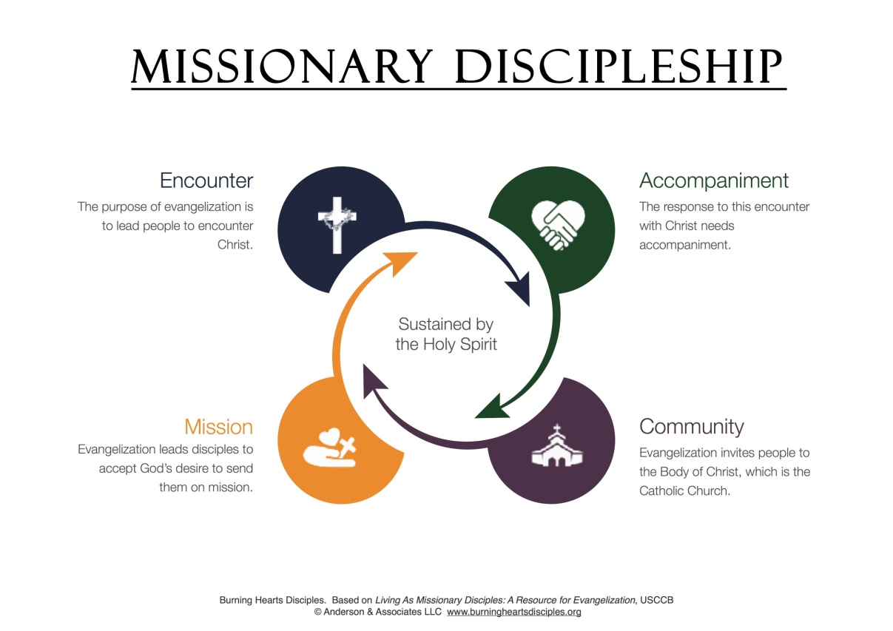

*Nevertheless, I want to emphasize that what I am trying to express here has a programmatic significance and important consequences. I hope that all communities will devote the necessary effort to advancing along the path of a pastoral and missionary conversion which cannot leave things as they presently are. “Mere administration” can no longer be enough. Throughout the world,*

*let us be “permanently in a state of mission”.*

- Pope Francis, Evangelii Gaudium #25

**ENCOUNTER**

**Missionary discipleship begins in the encounter each person has with our Lord, Jesus Christ, and proposing the transforming power and love of Jesus Christ to others.**

* To encounter involves receiving the proclamation of the Gospel, through the kerygma, the Person of Christ, or   
  through another’s gracious witness and mercy.
* Seeking and facilitating encounter with the Lord must be   
  encouraged at all times, among ourselves and with others.
* Encountering Christ requires a response, which is a form   
  of prayer.
* Encountering Christ begins a relationship that should grow, and we must intentionally foster that relationship and   
  ongoing encounter with the Lord through the sacramental   
  life of the Church, the well of salvation.
* The joy of this encounter-based relationship *must give   
  witness* to others.



**“Modern man listens more willingly to witnesses than to teachers, and if he does listen to teachers, it is because they are witnesses.”**

-Pope Paul VI, *Evangelii Nuntiandi* #41

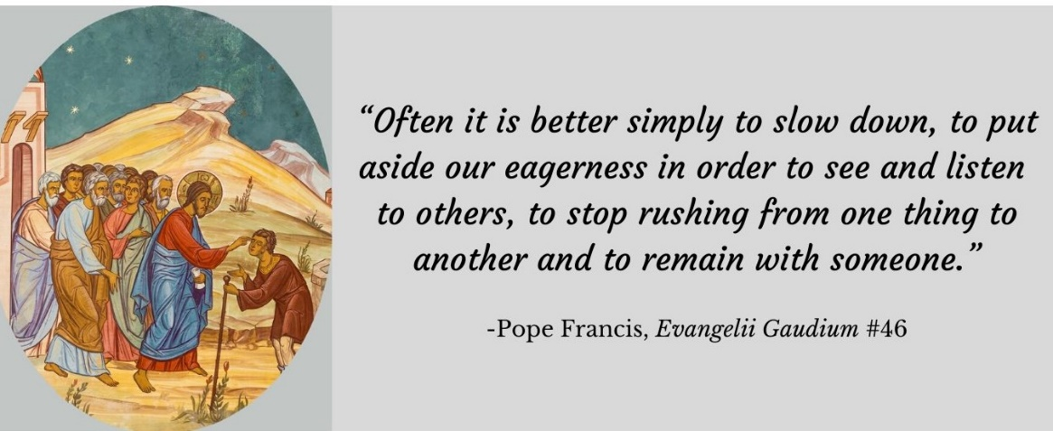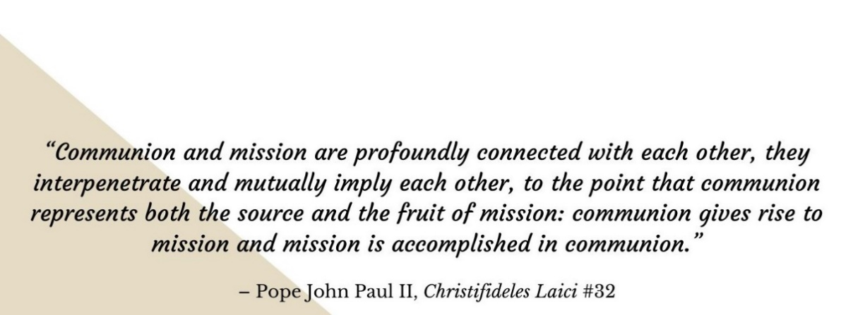

**ACCOMPANY**

**Accompaniment is walking with others on the path to a deeper life of discipleship in Jesus Christ. It is both a willingness to learn from the wisdom and example of**   
**our fellow Christians, and the intention to share   
with others the faith that is ours.**

* The practice of accompaniment begins with hospitality, by generously welcoming others into our lives and offering   
  them the gifts of our time and attention.
* Accompaniment involves inviting others into a friendship rooted in Christ, and into a mentoring relationship that encourages and guides them in their relationship with Christ.
* Accompaniment requires patience and the gift of our   
  presence. It resists “efficiency” and time constraints.
* Accompaniment seeks to understand, to listen, and to accept our sister or brother, and also to guide, to encourage, and to invite them into a deeper experience of faith.

**BE IN COMMUNION**

**It is too easy to consider church community as another special interest group. The only way to overcome this self-limitation of community is to recognize the center   
of our communal life, Jesus Christ, and honor how   
the Holy Spirit empowers us to turn to Christ and   
offer Christ to others.**

* To be in communion is to incarnate hospitality, generosity with those within *and* those outside the practicing community.
* To be in communion is to pray together, through Eucharistic liturgy and in small groups (through adoration, *lectio divina*, the Divine Office, praying the rosary, and/or offering the joys and pains of life to the Lord together).
* To be in communion is to draw upon the Holy Spirit to recognize and honor the gifts and talents each person contributes to the whole, including the more unusual gifts that facilitate evangelization.
* To be in communion is to recognize that obedience has an   
  important role for everyone, fostering humility, docility, and   
  deeper listening to Jesus Christ through the magisterium of the Church he founded.



**“When he saw the crowds, he had compassion on them, because they were harassed and helpless, like sheep without a shepherd. Then he said to his disciples, ‘The harvest is plentiful but the workers are few. Ask the Lord of the harvest, therefore, to send out workers into his harvest field.’”**

(Matthew 9:36-38)

**Our Church exists to   
seek the lost.** **We need to   
be focusing outward,** **and   
attend to challenges of**   
**maintaining resources only if   
they help** **us reach and offer Jesus Christ to the lost.**

* To send is to give deliberate witness of your   
  discipleship to Christ, and deliberately invite and   
  encourage others to witness to someone else.
* To send is the engine of the Church– the first three   
  elements are the fuel.
* To send is witness that we live in a reality of perennial Pentecost:   
  The Holy Spirit desires to use us to evangelize any place and everywhere  
  at any time.

**SEND**