Welcome to ConnectNow Accounting! The following guide was designed by Diocese of Winona and ParishSOFT as a companion to the ConnectNow Accounting Training Guide. It will assist you as you begin using your new accounting software.

Get Connected

Go to your ConnectNow Fund Accounting Site where your data is now “live”!

1. Go to https:// winona.connectnowaccounting.com and enter your User Name and Password
   1. Username =
   2. Password = (default is “pass”)

If you would like to continue to use the Training site to practice entering data, or train new staff:

1. Go to https:// winonatraining.connectnowaccounting.com and enter your User Name and Password
   1. Username =
   2. Password = (default is “pass”)

Please, complete the checklist below as you work through the instructions that follow to ensure the best experience.

**You will need:**

* ConnectNow Training Guide
* Completed Mapping Document
* Reports from Prior Accounting System
  + Statement of Financial Position (Balance Sheet) as of 7/1/14
  + Trial Balance Summary Report: One for each month between 7/1/12 – 7/1/14 if going 2 years back or 7/1/13 – 7/1/14 if going 1 year back and current month
  + 1099 Vendor List with Calendar Year to Date Totals
  + Unpaid Bills List
  + Last Bank Reconciliation Report -or- a list of all uncleared checks and deposits for each bank account

**Getting Started**

* Select Accounts from Completed Account Mapping Document
* Add Sub-accounts
* Enter Vendors and 1099 Vendors
* Vendor Account Distribution
* Enter Open Bills

**Before Months are Closed**

* Enter Prior Year Uncleared Checks
* Enter Prior Year Uncleared Deposits
* Enter Beginning Balances
* Enter Fiscal Year-to-Date Monthly Journal Entries (if going 1 or 2 years back)

# ****Selecting Accounts****

Using your completed Chart of Accounts Mapping Document as a guide, select the accounts you would like to use in ConnectNow.

***TIP****: Searches that are too specific will return no results. Hit “Show All” to reset the search options.*

Your diocese has provided you with a full Chart of Accounts that you will use. These accounts have been inserted into your ConnectNow Fund Accounting system and are ready to use.

1. Click on the **Accounts** Icon
2. When in the **New Account** Screen, click the **Chart of Accounts (Add Sub-Account)** link.  
    - The items with a checkbox have not yet been inserted in the Chart of Accounts.

Remember to:

***TIP:*** *If you click on “add sub-accounts”, any accounts you have checked will be unchecked. Click* ***Submit (Alt+S)*** *before adding any Sub-accounts.*

* Use the search options to narrow down the account list to a single entity (or more specific when searching for just a few accounts)
* Click “submit” (Alt+S) to add the selected accounts

(*This procedure is defined on pg. 11 of your training guide.)*

Adding Sub-Accounts

Sub-accounts allow parishes to create multiple of the same account type or use more specific descriptions than are provided in the standard chart.

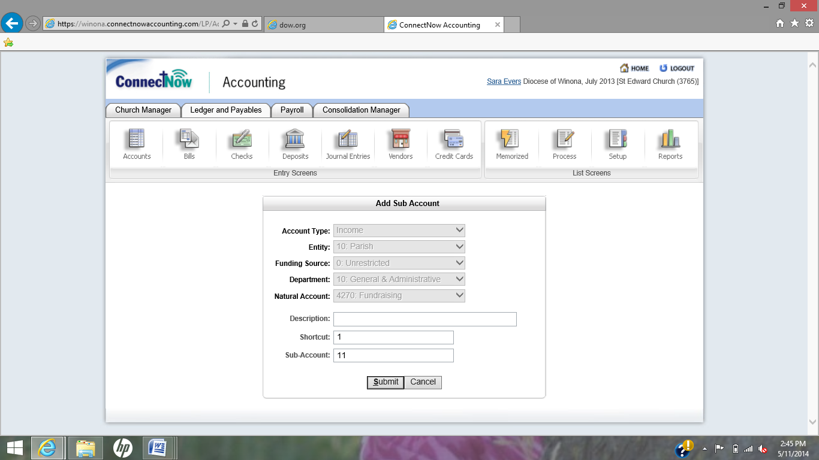

1. Click on the **Accounts** Icon
2. Click the **Chart of Accounts (Add Sub-Accounts)** link.
3. Click the **Add Sub-Account** link under the main account number.
4. The system will copy all of the elements of the account, allowing you to change the **Description** and **Shortcut Number.**
5. Click **Submit**.

Sub-accounts may be added for the following accounts:

Account Types: ALL

Account Numbers: ALL

Sub-Accounts Numbers: 21 - 99

When sub-accounts are added, please follow these guidelines:

***TIP:*** *If you do not need the main account number that the Diocese provided,* ***you are not required to select it*** *to insert a sub-account.*

**Main Account Number:** Main account number does not need to be chosen

**Description Guidelines:** Description as location chooses.

**Description Example:** Flower Fundraising

Shortcut Formula: Account # - Department - Sub-Account # - EntityID - Funding Source

Shortcut Example: 4270GA21P00

**TIP:** Descriptions cannot be changed after being submitted.

(*This procedure is defined on pg. 11 of your training guide.)*

# Enter Vendors

**TIP**: Before you add a new vendor, look for the vendor’s name in the **Quick Find** or **Find Record** list to ensure that the vendor is not already set up in your system. It is best to look for alternate spellings as well.

Using your detailed vendor list, it is important to enter your 1099 and most frequently used vendors before starting to enter transactions. Make sure to enter 1099 vendors’ Calendar Year to Date Totals (if applicable) to ensure that proper amounts are reported to the IRS.

To add a new vendor, click the **Vendors** icon.

Before you add a new vendor, look for the vendor’s name in the **Quick**

**Find** or **Find Record** list to ensure that the vendor is not already setup in your system. This quick search helps to ensure that you don’t have duplicate vendors in your database.

* **Vendor Name**: Enter the name of the vendor.
* **Check Name**: Enter the name as it should print on your checks.
* **Address, Address 2, City, State, Zip Code, and Country**: Enter the vendor’s complete mailing address.
* **Account Number**: Enter the vendor’s account number for your organization’s account.
* **Terms**: If you have established Vendor Terms (available from the Setup screen), those options will be available for selection from this lookup table. Selecting terms for a vendor will automatically populate the **Due Date** and **Discount Date** on any bills entered for this vendor.
* **Type**: If you have established Vendor Types (available from the Setup screen), those options will be available for selection from this lookup table.
* **Contact, Phone Number, Cell Phone, Fax, Email**: Enter details for the primary

contact person within the vendor’s business organization.

* **WebPage**: Enter the vendor’s website. Click the **Submit** button to save the record.

The Vendor’s name will now be available from the Vendor lookup tables in the software.

*NOTE: The* ***Account Distribution****,* ***1099/Checks****, and* ***Credit/Notes*** *options at the top of your Vendor screen will be dimmed/unavailable until you have clicked* ***Submit*** *to save the new vendor record*

(*These procedures are defined on pg. 13 of your training guide.)*

# Vendor Account Distribution

If a vendor is to be paid from multiple accounts, you can save data entry time by setting and saving distribution options in the vendor record. You can then apply them (or opt not to apply them) to bills entered for that vendor.

To set up distribution options, complete the following steps:

1. 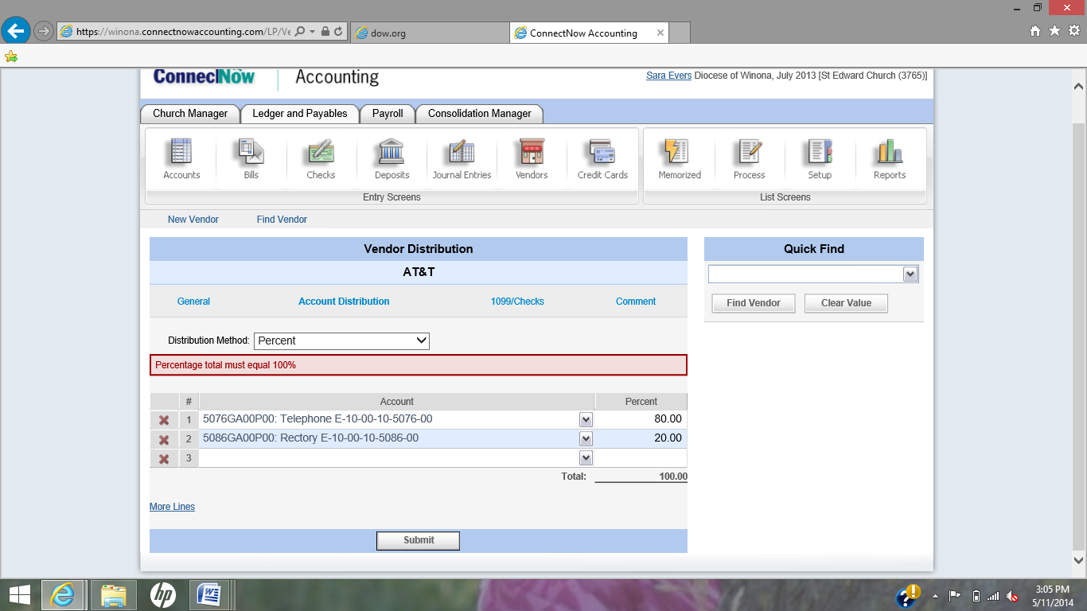Click the **Vendors** icon on your toolbar.
2. Find and view the vendor record.
3. Click **Account Distribution**.
4. Click the pull down menu for Distribution and choose **Amount** or **Percent**
5. Click in the row #1 **Account** lookup table, choose the first account, and enter the amount/percent of the distribution in the **Amount/Percent** field.
6. Click in the row #2 **Account** lookup table, choose the second account, and enter the amount/percent of the distribution in the **Amount/Percent** field.
7. Add additional accounts and amounts as needed. If you need to add more than three accounts, <**Tab**> to the **More Lines** link and press <**Enter**> to add two additional rows to the list.
8. Click the **Submit** button to save the account distribution information to the vendor record.

Each time you enter a new bill for a vendor that has an account distribution, you will be asked if you wish to apply the distribution options to the bill.

Click **OK** to apply the distribution or click **Cancel** to add a bill without the distribution amounts. If you click OK, the accounts will be listed on the *Bill Information* screen. You can edit or delete the accounts if needed.

(*These procedures are defined on pg. 14 of your training guide.)*

# Enter Open Bills (Using accrual accounting method)

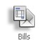Since you will be entering the Beginning Balance for your Accounts Payable account, you will need to enter the prior year unpaid bills as a “pseudo bill”, which will have no affect on your Accounts Payable balance.

1. From Ledger & Payables, click Bills.
2. If you have more than one Accounts Payable account, select the appropriate Accounts Payable account.
3. 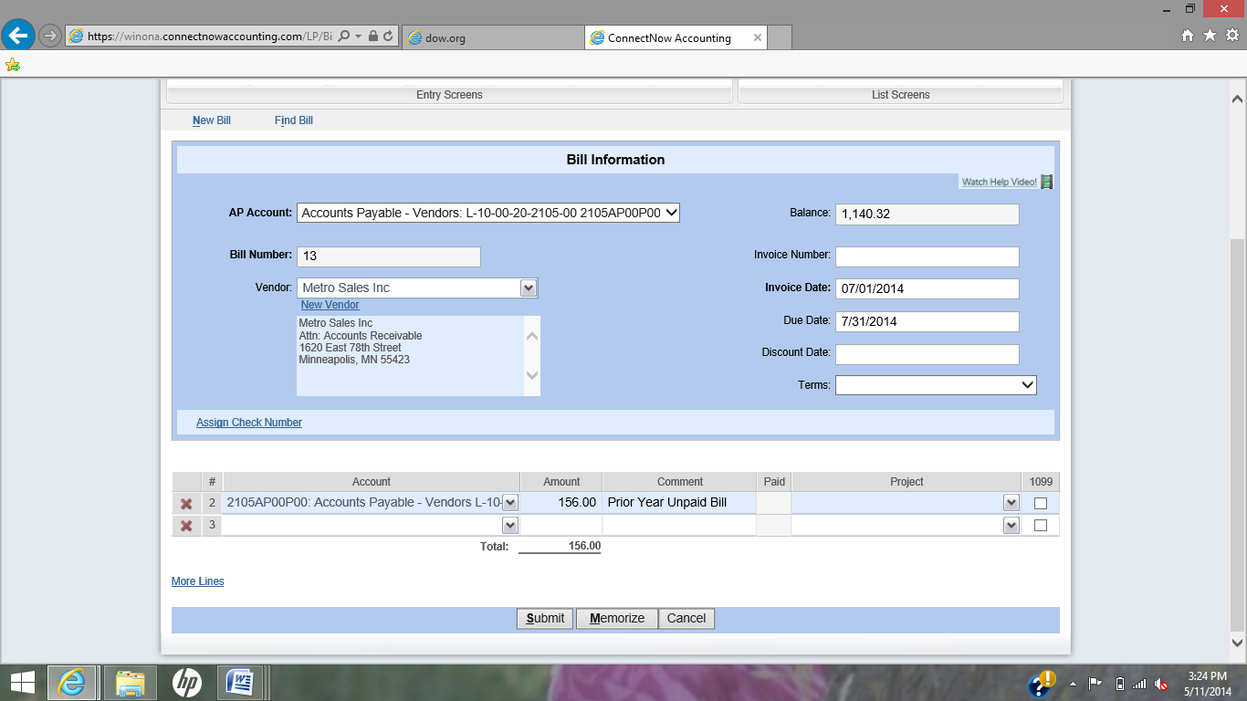Create a bill for the vendor that was entered in a prior fiscal month/year that has not yet been paid. Use the first day of your current fiscal year in the Invoice Date field. (July 1, 2014)
4. Under Item #1, enter the **SAME SHORTCUT NUMBER AS YOUR ACCOUNTS PAYABLE ACCOUNT**, and then enter the amount of the bill and a comment such as, Prior Year Unpaid Bill.
5. Click Submit.

This bill will now be available to pay, but will not affect your previous Accounts Payable balance until the bill is paid.

**TIP**: If you have more than one Accounts Payable account, select the appropriate Accounts Payable account.

After entering all prior year unpaid bills, click Reports | Transactions | Bill List and print a list of the bills to be paid. This total of those unpaid bills should equal your Accounts Payable Beginning Balance.

# **Enter Open Items for Bank Reconciliation**

Using the last month’s bank reconciliation report as a guide, find any transactions that had not cleared in the bank statement and use the following procedures to record them in ConnectNow.

Prior Year Uncleared Checks (Pseudo Checks)

You can create a “pseudo check” in ConnectNow that will be available to clear on your Bank Reconciliation, but won’t affect your account balances. This is done by entering a bill and manual check.

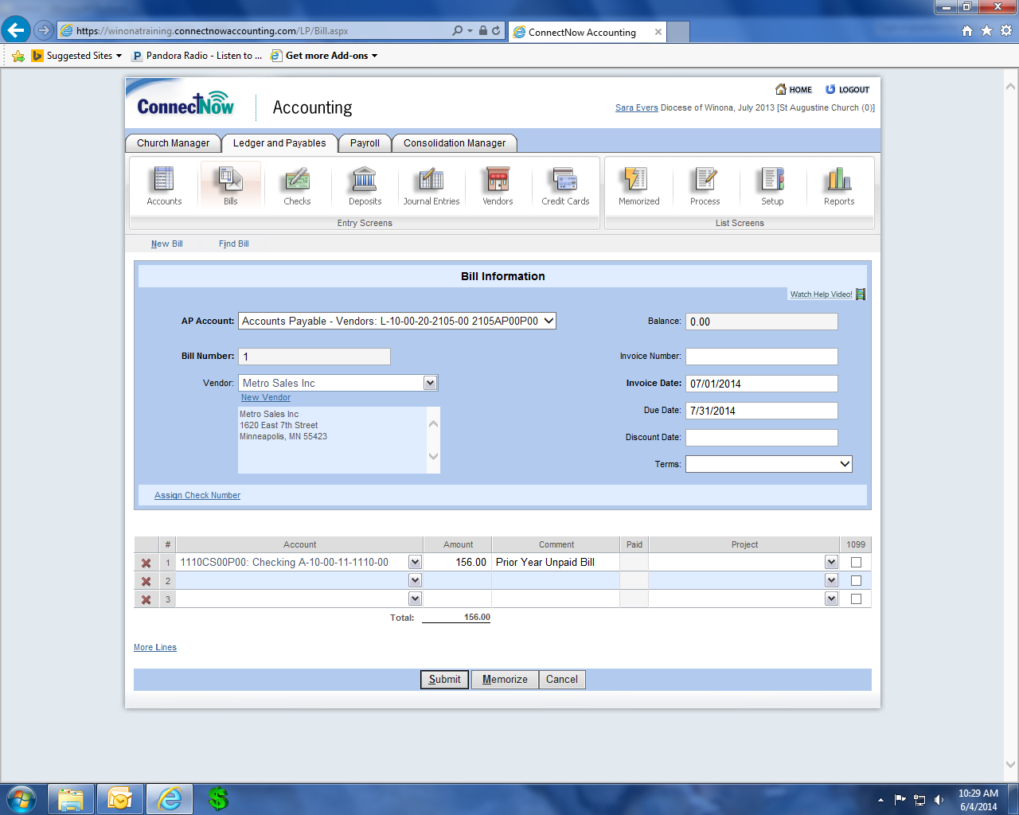

1. From Ledger & Payables, click Bills.
2. Select the accounts payable account.
3. Create a bill for the vendor that was paid with a check from a prior month/year that has not yet cleared your bank. Use the first day of your current fiscal year in the Invoice Date field.
4. Under Item #1, enter the **SAME SHORTCUT NUMBER AS YOUR BANK/ASSET ACCOUNT**, and then enter the amount of the check and a comment such as, Prior Year Uncleared Check.
5. 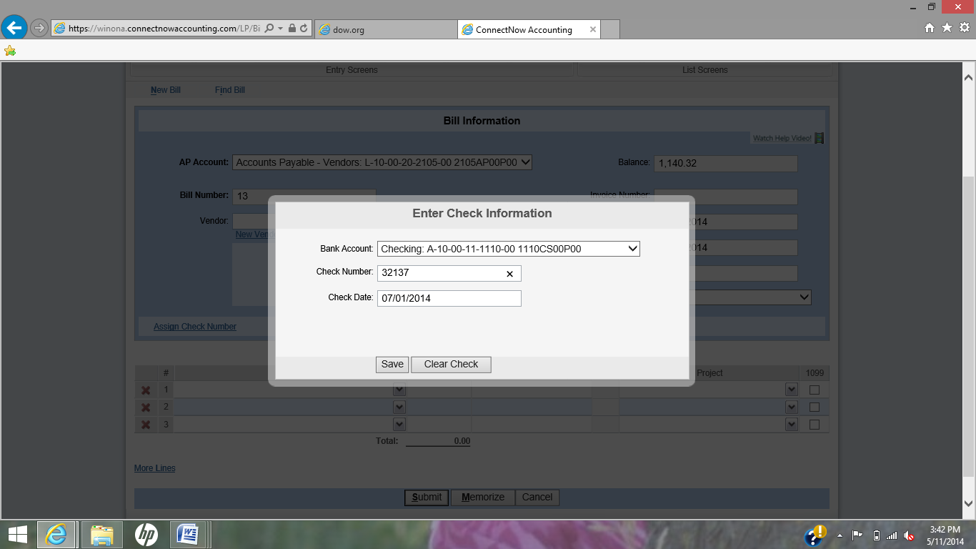Click the Assign Check Number link. Assign the original check number of the check from the prior month/year that has not cleared your bank, and use the first day of your current fiscal year in the check date field. Click Save and Submit.

(*The general bill and check procedures are defined on pg. 17-20 of your training guide.)*

Prior Year Uncleared Deposit

You can create a “pseudo deposit” in ConnectNow that will be available to clear on your Bank Reconciliation, but won’t affect your bank balance.

**TIP**: If you have more than one bank account, be sure to select the appropriate bank account.

1. From Ledger & Payables, click Deposits.
2. If you have more than one bank account, select the appropriate bank account.
3. Use the first day of the current fiscal year in the Deposit Date field. (July 1, 2014)
4. 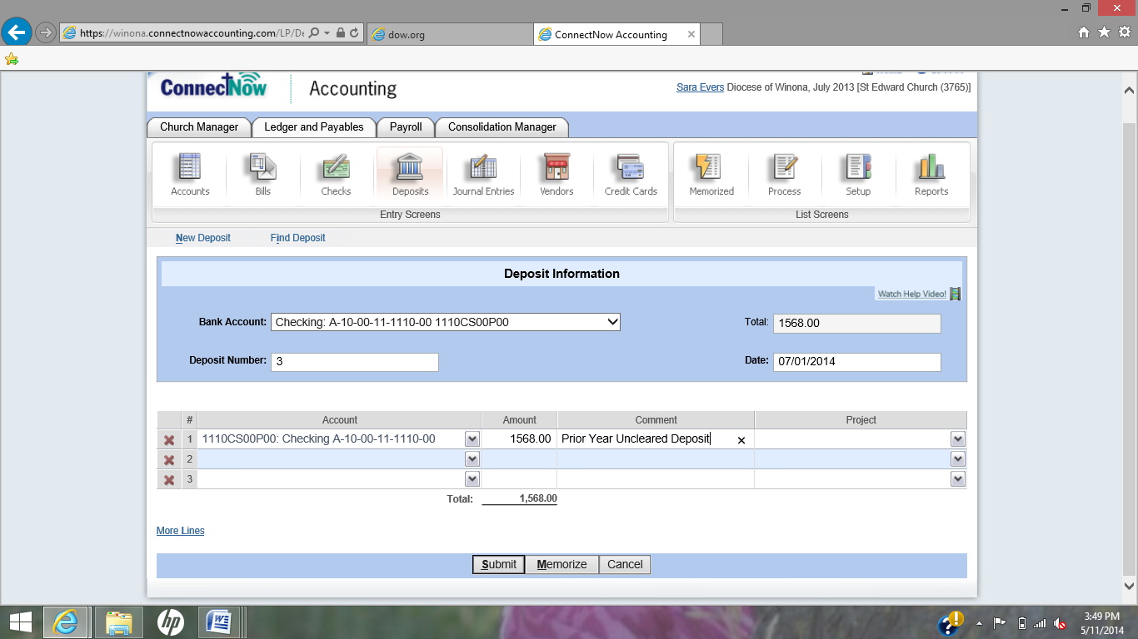Under Item #1, enter the **SAME SHORTCUT NUMBER AS YOUR BANK/ASSET ACCOUNT**, and then enter the amount of the deposit and a Comment such as, Prior Year Uncleared Deposit.
5. Click Submit.

# (The general deposit procedure is defined on pg. 26 of your training guide.)Beginning Balances

Use the Statement of Financial Position (Balance Sheet) as of 7/1/14 from your previous accounting system as a guide for your Beginning Balance entries. Beginning balances must be entered for the following accounts:

|  |  |  |  |  |
| --- | --- | --- | --- | --- |
| **Account Type** | **Typical Account** | **Typical Balance** | **Debit Effect** | **Credit Effect** |
| Asset | Savings | Debit | + Increase | - Decrease |
| Liability | Mortgage | Credit | - Decrease | + Increase |
| Net Asset | Equity | Credit | - Decrease | + Increase |

**

*NOTE: Beginning balances are not applicable to income and expense accounts.*

# Enter Beginning Balance

* 1. Click the Process button
  2. Choose Beginning Balance.
  3. Enter the first day of your current fiscal year in the Date field.
  4. To enter the balances of an Asset Account (Checking Account, Savings, Petty Cash, etc.)
     1. Debit (Increase) the Asset Account
     2. Credit (Increase) the Net Asset Account (a.k.a. Fund Balance or Retained Earnings)
  5. To enter the balances of a Liability Account (FICA, Federal Taxes, Church Mortgage, etc.)
     1. Credit (Increase) the Liability Account
     2. Debit (Decrease) the Net Asset Account (a.k.a. Fund Balance or Retained Earnings)
  6. Be sure debits equal credits.
  7. Click Submit when complete.

# **(The beginning balance procedure is defined on pg 36 of your training guide.)**